PAUL HINDEMITH’s SONATA FOR PIANO FOUR HANDS: AN ANALYSIS AND CRITICAL EVALUATION OF THE PRINTED EDITION
BASED ON THE COMPOSER'S RECORDED PERFORMANCE
by
KSENIA ILINYKH

B.M., University of Utah, 2010

M.M., University of South Carolina, 2012

A Doctoral Document, in support of the Lecture-Recital project, submitted to the
Faculty of The College of Music of the
University of Colorado in partial fulfillment
of requirement for the degree of
Doctor of Musical Arts
2017

Abstract
Ilinykh, Ksenia (D.M.A., Piano Performance)
Paul Hindemith’s Sonata for Piano Four Hands: An Analysis and Critical Evaluation of the Printed Edition Based on the Composer's Recorded Performance
Thesis directed by Professor Andrew Cooperstock

This research is a tribute to Paul Hindemith, who was not only an important composer but also a well-regarded pianist and interpreter of his own works. Primarily, he was famous as a chamber composer who wrote a sonata for every instrument. His Sonata for Piano Four Hands did not gain as much popularity as his other piano works, but it stands out among his piano works as a unique cycle. A recorded interpretation of the composer’s rendition of the Sonata, and the only recording of Hindemith at the piano, provides invaluable insight into Hindemith’s performing style and interpretative intentions.
Chapter One provides a profile of the composer and his views on the piano as an instrument. Chapter Two provides data on the historic background of the Sonata and information on the collaborative partnership between the composer and pianist Jesús Sanromá. It is based upon his letters and impressions from the contemporaries. Chapter Three delves into Hindemith’s performing style and analyzes a few important points heard in the recording. It primarily focuses on such specific details as articulation and phrasing, and their relevance to the printed score.
Table of Contents
Abstract 1

Introduction 3

Chapter One
Hindemith as Composer and Pianist 4

Chapter Two
Sonata for Piano Four Hands (1838): Historical Background 7

Chapter Three
Hindemith’s Performing Style as Seen through His Performance of the Sonata for Piano Four Hands 9
Slur 10
Tenuto 11
Staccato and Accent 17
Conclusion 19
Appendix 20
Bibliography 29
Transcription of the Printed Score Based on the Recorded Performance…………………………...30

Introduction
Often, student performers see the works of Hindemith as dogmatic and complex. It is true that, at first glance, Hindemith’s score might puzzle with its quick rhythmical and metrical shifts, meticulous tempo changes, and precise articulation and dynamic signs, leaving seemingly little room for a performer’s interpretative ideas. Confused with an abundance of signs, many read Hindemith’s directions in the score not as suggestions, but rather as prescribed instructions, and treat unmarked sections, or less-marked sections, as less expressive transitions. Although modern generations of performers cannot communicate with the composer, we can, thankfully, draw upon the knowledge of performance practice, memoirs about the composer, and the composer’s recordings and interviews, all of which can inform our performance of the piece.
The biggest influence on my understanding of how to read the score of the Sonata for Piano Four Hands was the only recording of Hindemith’s piano playing. It served as a great tool to recognize his performative ideas behind the silent musical text. Another helpful source on the performance practice of Hindemith’s music was the article “An Interview with Keith Wilson on Hindemith’s ‘Symphonic Metamorphosis’”, in which Keith Wilson, a band conductor from Yale, talks about his collaboration with Hindemith and composer's way of marking a score. It was nearly the only source that I could find the composer’s remarks on how to perform his music. I found it very valuable, even though these words were spoken from the third person. Both sources, the recording and the article, illuminated the score as a written document of the composer’s suggestions and his interpretative views. These two sources served as communicative transits between the early 20th-century composer and the modern performer.

Chapter One: Hindemith as Composer and Pianist
Paul Hindemith was born in Hanau, close to Frankfurt am Main, Germany, and was taught the violin during his school years. Although an excellent pianist, we have no information on his piano teacher. He entered Frankfurt’s Hochschule Konservatorium studying violin, conducting, and composition. During his active compositional years, his music was pronounced by the Nazi Party as “degenerate” and “atonal noisemaker.” It was after he immigrated to the USA and became a citizen that he had more freedom to compose, perform, and conduct his music to the open-minded audience of the West. While teaching at Yale University, he established himself as a prominent writer of such important treatises as The Craft of Musical Composition. Most of the composer’s music portrays a tonal, but non-diatonic, system, which switches among several tonal centers.
One of the key features of his system is that he ranks all musical intervals of the 12-tone equally tempered scale from the most consonant to the most dissonant. He classifies chords in six categories on the basis of how dissonant they are, whether or not they contain a tritone, and whether or not they clearly suggest a root or tonal center. Hindemith's philosophy also encompassed melody—he strove for melodies that do not clearly outline major or minor triads.
Having attended a performance of Hindemith's Neues vom Tage, an anonymous critic writing in Opera magazine in 1954, noted that "Mr. Hindemith is no virtuoso conductor, but he does possess an extraordinary knack of making performers understand how his own music is supposed to go."
While a prominent composer, Hindemith was also a multi-faceted performer, primarily famous for his talent as a violist and violinist. There is no information on Hindemith’s piano training, but his legacy of piano works shines with outstanding pieces. His piano recording portrays brilliant skill. His piano works not only stand out as noteworthy concert pieces, but are also very idiomatic. In the chapter “Performers” of his famous book A Composer’s World, Hindemith spends three sections on description of the keyboard action, its sound production, and historical evolution. He talks about keyboard instruments as a historian and a multi-instrumental composer who thinks of instruments in relation to one another. He mentions positive and negative qualities of each of the instruments, not giving preference to one or another. Regarding the piano, he says: “Remove the keyboard from a piano and what remains is basically a harp.” He thinks of the piano as a stringed instrument first, and then as an instrument individualized with hammers. “A hammer will always and basically remain a tool that lengthens and modifies the hand's actions, and the fact that it is covered with tender felt cushions and is equipped with numerous additional refinements will never make it equal to the violin player's finger that touches the string without any intervening transmission of forces. Pianists do not appreciate such statements.” As a string player primarily, it is no surprise that he thinks of piano as a stringed instrument first. However, he also compares the piano to yet a different kind of instrument: “Whatever the pianist does, using intellect, hands, and lever arrangements in the process of enlivening musical forms, will always be derived from musical experiences with the human voice.”
The piano played an immensely important part in Hindemith's compositional heritage, with more than half of his instrumental works partnering with it. As a solo instrument, the piano became for the composer an experimental laboratory for new sonorities, musical ideas, and implications of new theoretical findings. Hindemith said, regarding the Ragtime of his Suite “1922”: “Forget everything you have learned in your piano lessons. Do not worry whether you must play D sharp with the fourth or the sixth finger. Play this piece wildly but in strict rhythm, like a machine. Use the piano as an interesting kind of percussion instrument and treat it accordingly.” As Hindemith was orchestrally-minded, any character he marked on a page came from his multi-layered sound image, applied with perfect understanding of the tone and technique of the instrument he was writing for, where “each of the sonatas is like a musical portrait of the instrument for which it is written.” His ability to perform on each of the instruments he composed for was so refined that he did not have to worry about technical execution of the sound image he had in mind. The transition between sound image and its application was immediate for him. He composed sonatas for every instrument, highlighting their specific sound and tone, and his piano sonatas stand out with the depth of sound palate and variety of touch, as if he were writing for a compact version of an orchestra.

Chapter Two: Sonata for Piano Four Hands (1838): Historical Background
The Sonata was written in September of 1938 and published the following year by B. Schott’s Söhne. The final edition of the piece is Paul Hindemith- Complete Works, Piano Music II, ed. by Bernhard Billeter (Schott Music: 2009). The editions differ one from another. There are several issues with the first edition that are problematic in terms of performance. First, measure numbers are absent, and instead, rehearsal numbers are used. However, it creates a problem, as rehearsal numbers do not always indicate the change to larger sections. Rehearsal 10 is mistakenly placed in different measures between the two parts. Second, both parts lack consistent indication of meter change. While in the first movement the meter often switches every measure or two, the change is often not documented in both of the parts, complicating the performance side of the work. Third, while it is a standard practice for the primo and secondo parts to be placed side by side on two separate pages, due to the mentioned challenges above, it is difficult to trace and compare both parts. In the final edition of the piece, however, the primo and secondo parts are placed on the same page, rehearsal numbers are forfeited, and measure numbers are added.
From Hindemith's letters to his wife, we know that there were several performances and several recordings of this sonata with different partners on the primo part. The premiere of the work happened in Zürich in November of 1938 with Walter Frey, an instructor of piano at the Zurich Conservatory and an active concert pianist. Unfortunately, no reviews of their performance are left. The second performance was a year later in New York during Hindemith’s third piano tour with Ms. Hoffmann-Behrendt, whose “particular field is the interpretation of modern piano works." Their recital was noted as "successful" by the New York Times, though the Sonata was called arid. It was during this time that Hindemith recorded his piano sonata with Jesús Sanromá, the only recording of the sonata that is available today. Sanromá was Hindemith’s long-time friend and collaborative partner during the third American tour and to whom he also dedicated the Concerto for Piano and Orchestra (1945), and by whom it also was premiered. In the letter to his wife, Hindemith regards Sanromá as “an outstanding musician and as a pianist so splendid technically that it is pure joy to play with him.” He also mentions about Sanromá's characteristics as “his playing is first-class… [He] arrived fully practiced and played, apart from a few bars, fully in spirit of the composer.” He describes Sanromá in a very positive way as a collaborator with flutist Barrère: “The two are a wonderful duo; they make the piece more beautiful than it really is…. [they] blew the flute sonata magnificently. They made a very good impression, the large audience responded warmly at once. ” It is obvious that their effective partnership played a significant role during the tour, which produced successful performances and a recording available to all today.

Chapter Three: Hindemith’s Performing Style through His Recorded Performance of the Sonata for Four Hands
The following analysis compares Hindemith's interpretative style of the score with his written remarks. I used the last revision of the score as the master copy for the performance edition attached to the written document. To easily show the difference between the printed score and the interpretative decisions of the composer in the recording, the comparative table (Appendix A) was created. To show the results of the findings visually, I marked the composer’s performance style in the master copy with a red ink, trying to acknowledge as many details as I could. To analyze and annotate the recording, I used the program Sonic Visualiser. While it was easier to observe dynamics, articulation, and tempo fluctuations, it was challenging to inspect Hindemith's usage of the pedals, due to an unclear sound in the recording.
The recording of Hindemith’s performance uncovers a depth of musical and pianistic information helpful to any performer tackling the piece. Touch, articulation, dynamics, tempo fluctuations, and treatment of metronome signs are illuminated. Comparative analysis serves as a valuable guide for a more informed performance. Understanding the composer’s pianistic touch in his own piece is similar to participation in a dialogue, where one tries to understand motives and actions of the partner in an unfamiliar situation. Therefore, tackling a composition without an understanding of a composer’s interpretative intentions toward such important details as touch, articulation, and pedaling does not inform one’s pianism and technical approach to a piece. It is my intention to show that informed vision of the score creates better interpretative decisions.

Slur
The four types of articulation symbols marked by the composer in the score are tenuto, accent, staccato, and slurs. Among these symbols, the slur is the most undefined. The score indicates long slurs over motivic gestures, which is usually defined in standard notation as connected playing. However, in Hindemith’s playing, almost all of the slurs are broken with a disconnected touch. This non-legato touch that Hindemith uses to perform the notes under the slur is performed with a more defined, forward attack. While determining the coding on this type of sound during transcription, I decided to mark the gesture as tenuto under the slurred phrases. Such touch preserves the authentic identity of Hindemith’s heavier and separate sound of these notes accompanied by sustained pedal as seen in Example 1:
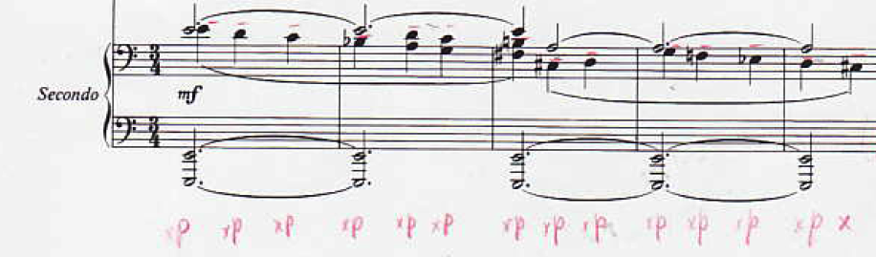
(Example 1)

As can be heard through the recording of Hindemith’s playing, the slur is a gesture that outlines a section or suggests general length of a phrase. Most often, the slur is written over a two-measure phrase, and the passages under the slur do not include any extra articulation. It is the responsibility of the performer to find smaller motives and organically weave them into the canvas of the larger phrase with an expressive articulation. Not ornamenting the score with additional details regarding articulation, Hindemith gives authority to the pianist to interpret to his or her best ability. The recording in this case serves an invaluable testimony regarding the mindset of the composer and tools he used to project his ideas.

Tenuto
Hindemith’s recording conveys the recurrent use of tenuto. Even though the composer does not always indicate tenuto in the printed score, he often applied it in the performance. He uses it in several different ways in order to emphasize the detailed nature of a motif and an expressivity of a metrical shift. Hindemith uses tenuto in following cases:
- Whenever the notes in the score are not marked with a slur as seen in measures 45-50 of the First movement:
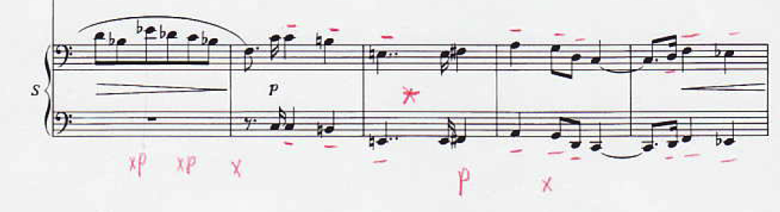
(Example 2)

- At the beginnings of the motivic phrases as seen in measures 59-64 of the First movement:
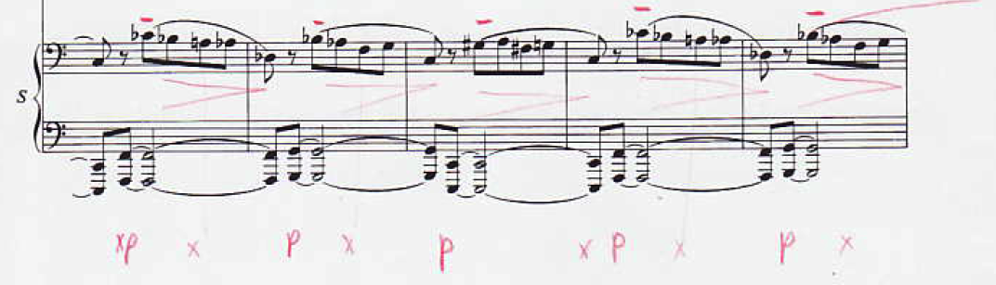
(Example 3)

This type of articulation is similar to the marked score in measures 78-79 of the First movement:
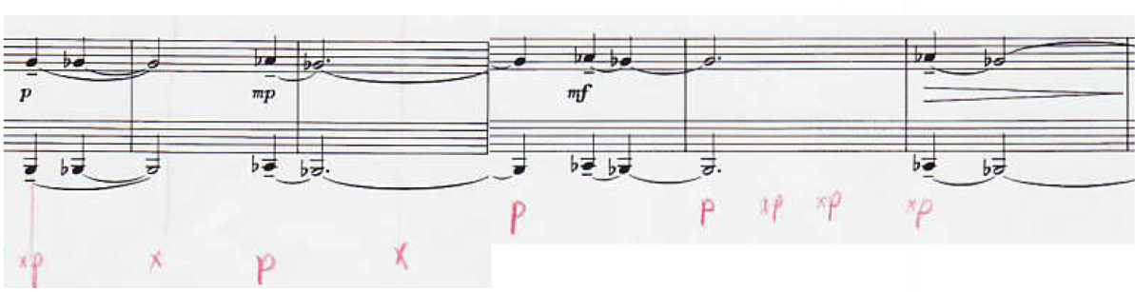
(Example 4)

- To emphasize the beginning of a motivic gesture in measures 97-100 of the First movement:
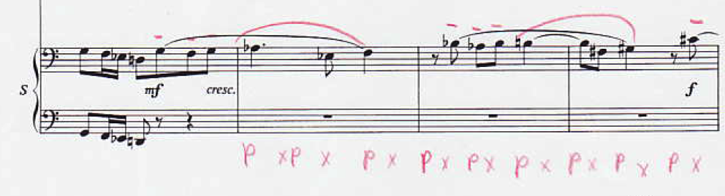
(Example 5)

Such articulation stresses more of a string or singing nature of the instrument (rather than percussive), as more emphasis is put into the expressive intervallic execution.
- To accentuate motivic gesture with more expressive details within a two-measure phrase, such as in measures 117-121 and in measures 136-141 of the First movement:
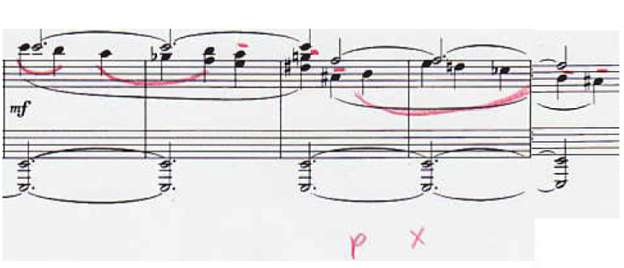
(Example 6)

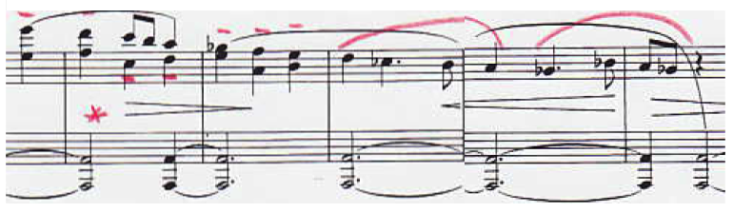
(Example 7)

Hindemith uses this technique similarly in measure 132 of the First movement within a shorter motivic gesture as seen in Example 8:
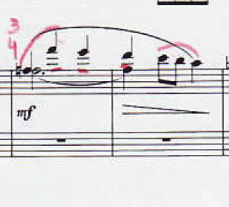
(Example 8)

- To emphasize the meandering nature of smaller motivic units in the Second movement, as seen in measures 67-69:
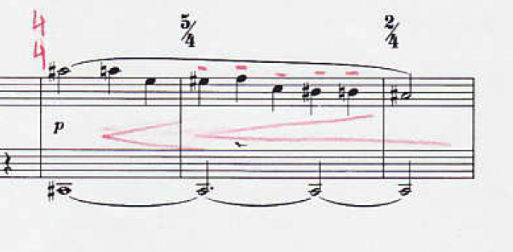
(Example 9)

- To predict an emergence of a highly energetic section in the Second movement, as seen in measures 54-55 and similarly when the A section returns in measures 144-145:
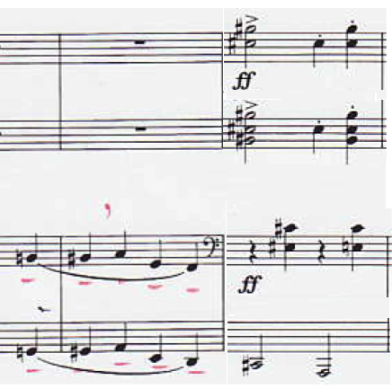
(Example 10)

- To bring a section forcefully to a quick but powerful culmination in the Second movement, in measures 37-40:
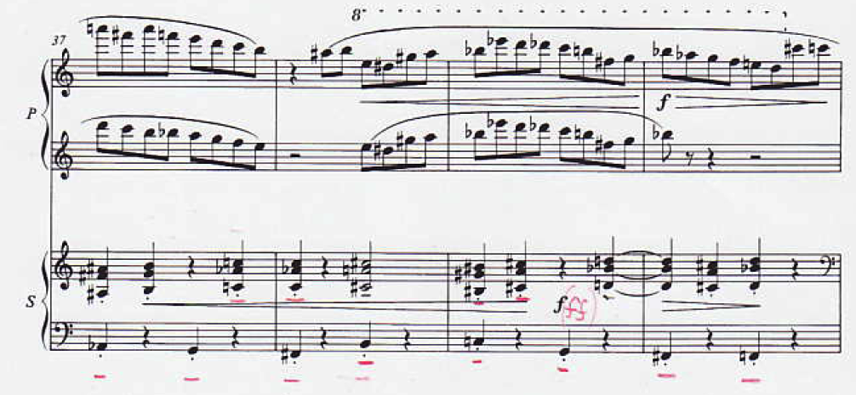
(Example 11)

- To emphasize metric shift and fluctuating flow of the phrase, as in the Second movement’s measures 67-70:
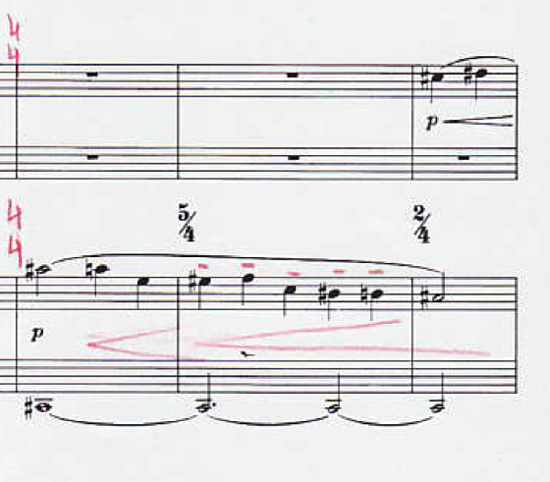
(Example 12)

Interestingly, the following phrase has the same motivic gesture, but is interpreted as written without any agogic marking. Without tenuto in the second part, and in conjunction with the rising primo part, a more linear sense of the phrase is created. However, Hindemith uses a dynamic variety again to emphasize the shift of the meter in the measures 70-74:
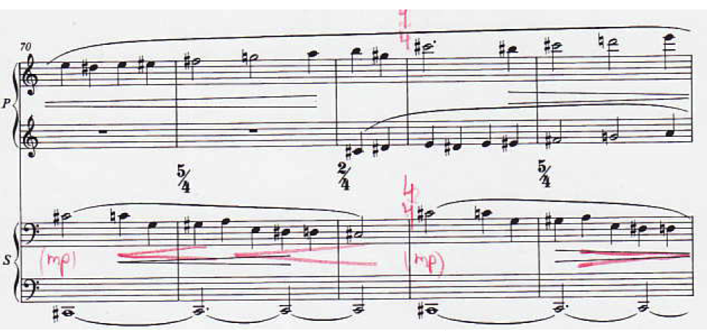
(Example 13)

Staccato and Accent
Staccato do not appear in the sonata until the Second movement, where they serve to build a highly spirited character. Together with other touches of tenuto and accent occurred in the movement, the character of the movement is evolving as highly energetic.
The accent is marked in the score frequently, especially in the primo part, and is often interchanged with the tenuto. The recording also shows accents in the secondo part used for extra expression.
As marked in the score for the primo part and thoroughly followed in the recording by Sanromá, the avoidance of the accent on the first beat gives a very dynamic flow to the phrases. However, Hindemith’s interpretation often omits the written accents, instead emphasizing the first beat, presenting a very animated character as can be seen in measures 14-19:
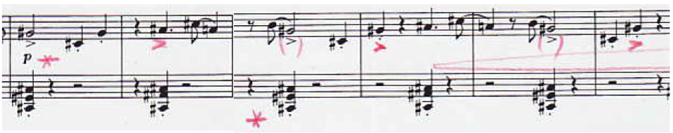
(Example 14)

In conjunction with the primo part, this type of articulation evolves as more collaborative, bold and play-like in measures 14-19 of the Second movement:
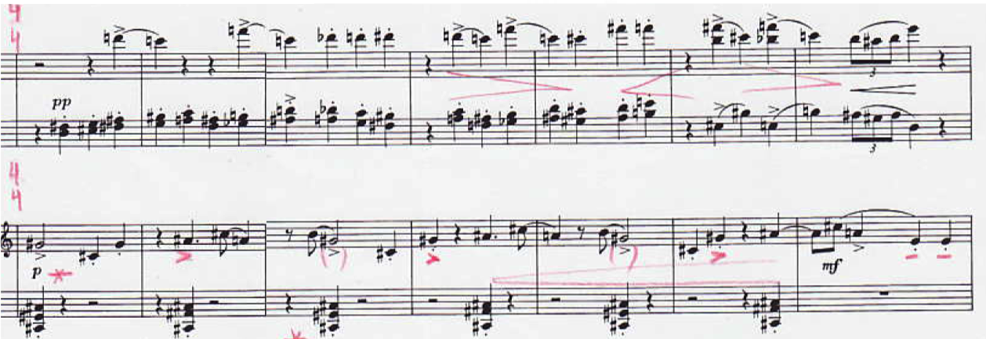
(Example 15)

Hindemith uses the accent to also emphasize abrupt nature of the phrases and its rapid move to its culmination in measures 29-32 of the Second movement:
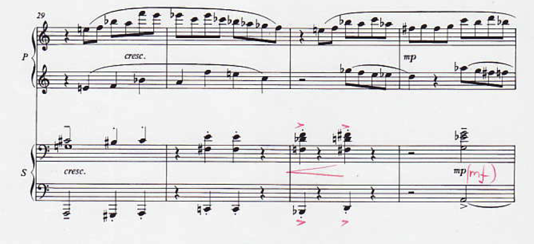
(Example 16)

Conclusion
Before I discovered the recording, I referred to Hindemith's score markings as the most accurate instructions regarding articulation and expressivity of the touch. However, after analyses of the recording, I observed that the composer's interpretation of his own score often differs from his written remarks. He often changes the tempo, adds articulation under the largely outlined phrases and breaks bigger motivic units onto the smaller motives. These additions seem to greatly enhance the character of each section that is marked with different character or tempo marking. Therefore, it leaves a modern performer with an abundance of opportunities to experiment with sound, dynamic, and pedals according to his/her aesthetic sense and performative imagination. The focus of this study was to foster an understanding of Hindemith at the piano—a task, which had never been addressed before. Analyzing the recording of Hindemith himself at the piano was a necessary tool toward a better comprehension and interpretation of his piano music. At least three most distinct factors could be implied from this comparative study of the recording and the score:
- The symbol of a slur in Hindemith’s writing serves as an outline of a bigger motivic gesture, inviting a performer to find and articulate smaller motivic units within;
- It is detrimental to find the most expressive articulative touch for each section that is indicated with different tempo remarks to convey a particular character;
- It is important to carefully consider and wisely apply even existing pedaling and tempo remarks written by the composer to create a more expressive performance.
It is my hope that the present comparative analysis of the composer’s interpretative style and published score will help other pianists to consider the composer's specific tempo indications, dynamics, articulation and pedaling in order to create a more meaningful and defined performance.

Appendix A
Comparative Table of the Piano Sonata for Four Hands recorded by Hindemith/Sanroma compared to the Printed Edition
First movement: Mäßig bewegt
mm.# | Second Edition | Hindemith/Sonoma Recorded performance
 | ♩=104 | ♩=112-117
Sonata-Allegro form:
-Exposition
(1-67)
-Development
(68-116)
-Recapitulation
(116-160)

Exposition
21 | mf | f
30 |  | ♩=114
37-Ein wenig einhalten |  | ♩=100
39-Ruhig | ♩=96 | ♩=96-100
52 |  | Hindemith arpeggiates an octave in the bass
54 |  | ♩=107
54 |  | Hindemith arpeggiates the octave in the bass
59
60
61
62
63
Development |  | ♩=107
84- Stets gemessen, nicht eilen |  | ♩=107
86 |  | mp
89 |  | ♩=110
91-Nicht eilen |  | ♩=118
102-103-Breit
106-107
109-110
114 |  | ritenuto
Recapitulation |  | ♩=107
131 |  | ♩=117
146 |  | ♩=104
147 | p | mp
147-Ruhiger, feierlich | ♩=66 | ♩=62

Second movement: Lebhaft
mm.# | Second Edition | Sanroma/Hindemith Recorded Performance
 | 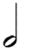=138 | same
A: m. 1-68  B (Trio): 69-131  A: 132-173 | Scherzo (ABA)
A

13 |  | The last motif in secondo is:
17-19 |  | In the secondo:
18-19 |  | In the primo:
21 | mf | In the primo:  In the secondo: poco crescendo
22 |  | In the primo:
27 | pp | In the secondo: mp
31 |  | In the secondo:
32 | mp | In the secondo: mf
33 | Crescendo at the end | In the secondo: on the first two beats
34 |  | f
39 | f | ff
42-45 |  | In the secondo:
56 |  | In the secondo:
58 |  | In the secondo:
60 |  | In the primo:
67-69 | p | In the secondo:
B
70 |  | In the secondo:
73 |  | In the Secondo: mp
79-80: Verschiebung | ppp
96
98 |  | In the secondo: pp
99 | pp | In the secondo: mp
101 | In the primo: | In the primo: pp
102 | p | mf
104 | In the primo: | In the primo: mp at the end of the diminuendo sign
104 | In the secondo: mp | In the secondo: mf
107 | In the primo: mf | Both parts: f
108 | In the primo: | In the primo:
111 | In the secondo: p | In the secondo: mp
119 |  | In the secondo:
120 | Both parts: cresc | In the secondo: mf
123 | Both parts: mp | In the secondo: mf
125 |  | In the secondo: f
130 | Both parts: f | In the secondo: ff
A
135 |  | In the secondo pick up to m. 136:

Third movement: Ruhig Bewegt
mm.# | Second Edition | Hindemith/Sonoma Recorded performance
 | ♩=54 | ♩=37
A: 1-42  B: 43-93  A: 94-134 | ABA form
A

4 | In the secondo: p | In the secondo: mp
5 |  | ♩=40
9 |  | In primo: ritenuto to the end of the measure
10 |  | ♩=34
11 |  | In primo: ritenuto to the end of the measure
13 |  | ♩=37
15 | In secondo: f | In secondo: mf
16 | In secondo: mf | In secondo: f
16 |  | ♩=45
17-18 |  | In secondo: the LH is played on legato
19-20 |  | In secondo: the LH is played on legato
19 |  | ♩=49
23 |  | ♩=52
29 |  | ♩=57
29 |  | In secondo: the fourth beat is played arpeggiated
30 |  | In secondo: the first beat,and similar chords are played arpeggiated
37 |  | ♩=60
B
48-52 |  | In secondo: the melody is on legato
72 |  | ♩=170
76 |  | In secondo: the LH is arpeggiated
A
99 |  | In secondo: the motivic slur is broken, and the pick up to m. 100 is slurred insted
100 |  | In secondo: the LH plays on staccato
102 |  | ♩=60
103 |  | In secondo:the sixteenth notes in the RH are on staccato
106 |  | In secondo: all sixteenth notes are played on tenuto, breaking slurred motive
114 |  | ♩=62
117 |  | ♩=65
120 |  | ♩=36
129 |  | In secondo: the last slurred motive is on tenuto, motivic slur is broken
132 |  | ritenuto

Bibliography
Foundation Hindemith. The Sonatas. Retrieved 18 Feb. 2015, from http://www.hindemith.info/en/life-work/biography/1933-1939/werk/the-sonatas/

Hindemith, Paul. A Composer’s Worlds: Horizons and Limitations. New York: Schott, 2000.

Hindemith, Paul. “Sonata For Piano Four Hands.” Recorded November 6, 1938. Schlott. Compact disc.

Hinson, Maurice. Guide to the Pianist’s Repertoire, 3rd edition. Bloomington: Indiana University Press, 2001.

Noss, Laurel. Paul Hindemith in the United States. Champaign: University of Illinois Press, 1989.

Powell, Edwin C. “An Interview with Keith Wilson on Hindemith’s ‘Symphonic Metamorphosis’.” Journal of Band Research 38 (2002): 37-48.

Reisman, Arthur. Turkey's Modernization: Refugees from Nazism and Atatürk's Vision. Washington, D.C.: New Academia Publishing LLC, 2006.

Schaeffer, Katherine. “College Hears Noted German Musicians Play.” Vassar Miscellany News (Poughkeepsie, NY), March 4, 1939.

Skelton, Geoffrey. Selected Letters of Paul Hindemith. New Haven: Yale University Press, 1995.

PAUL HINDEMITH’S SONATA FOR PIANO FOUR HANDS: TRANSCRIPTION OF THE PRINTED EDITION
BASED ON THE COMPOSER’S RECORDED PERFORMANCE

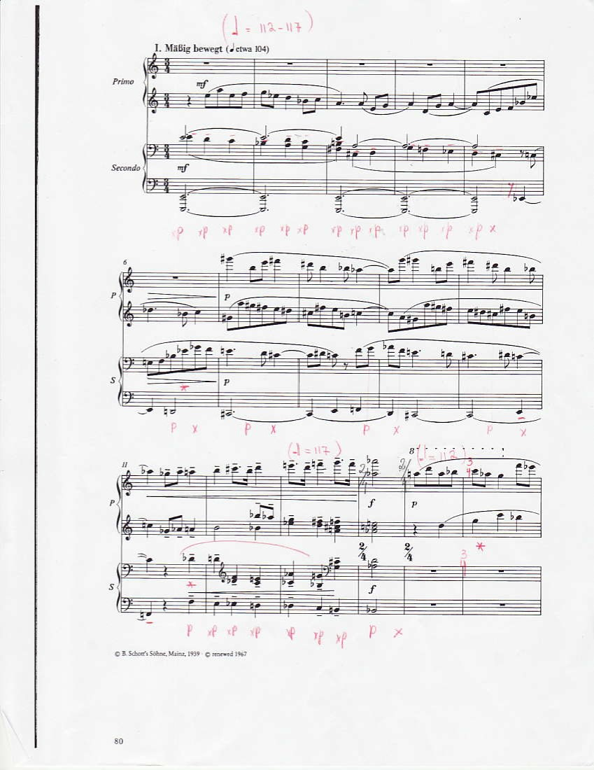

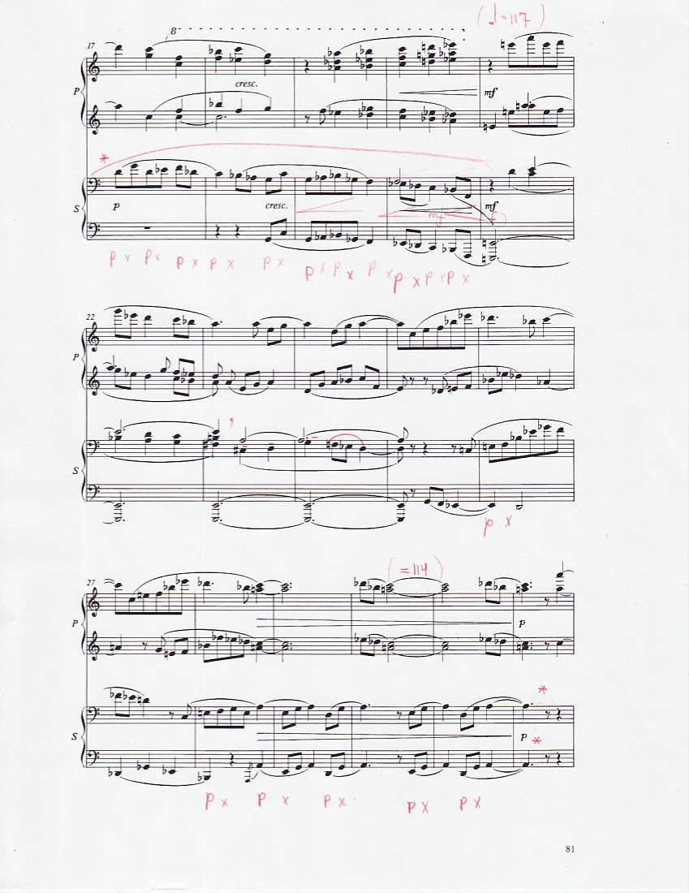

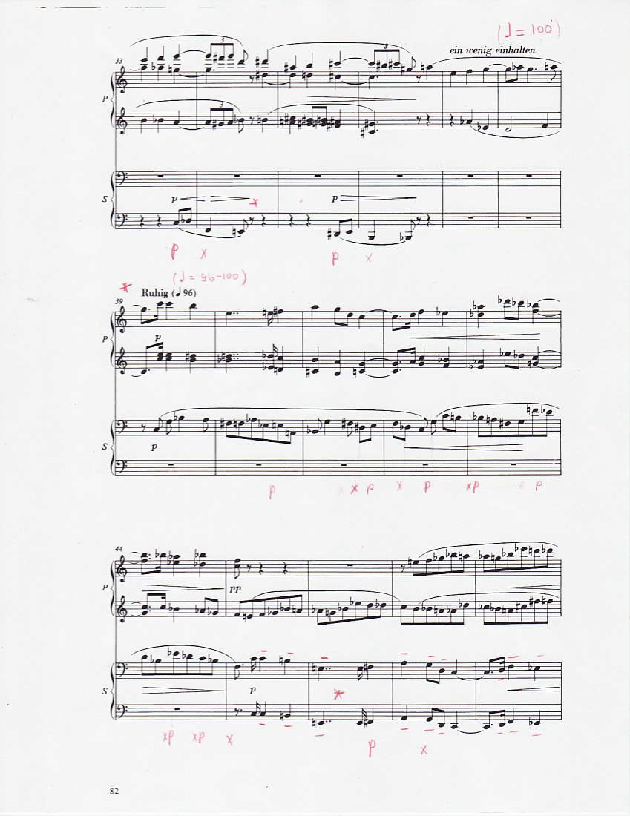
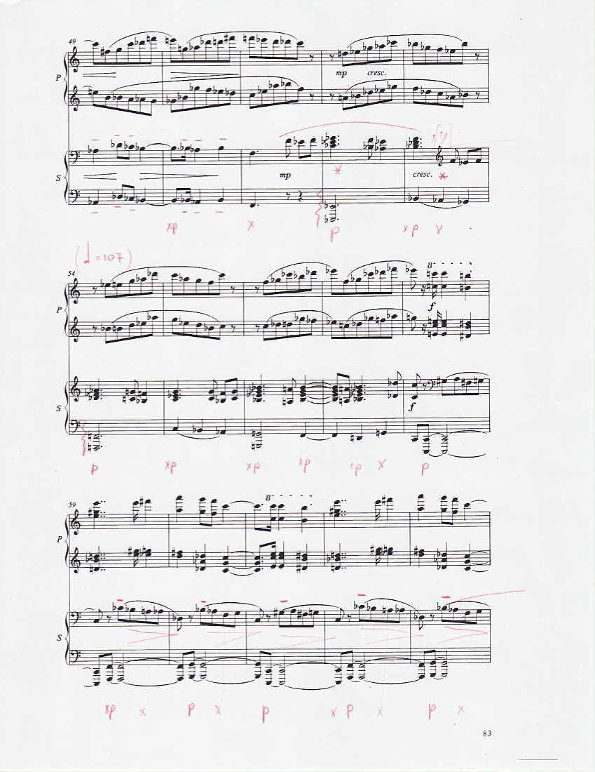

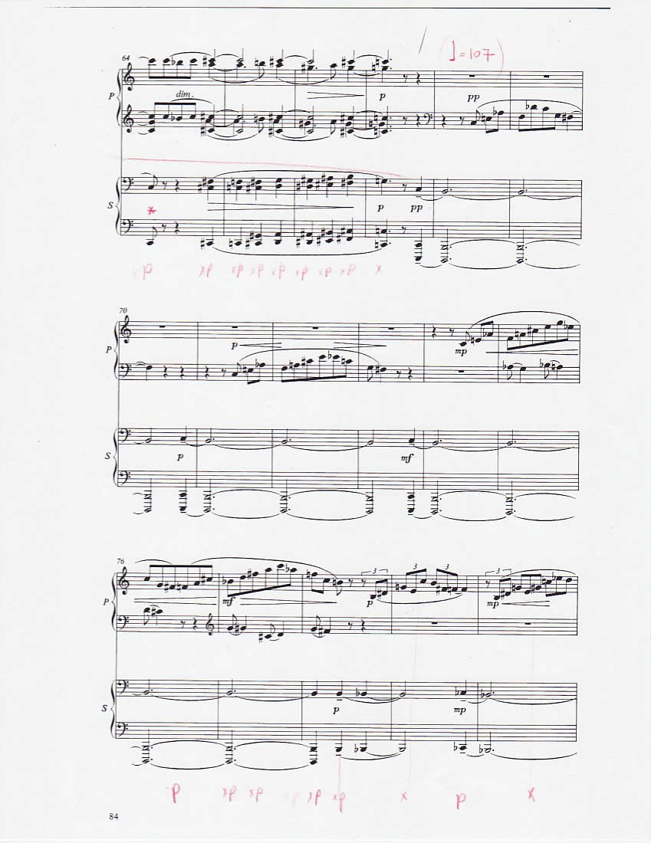

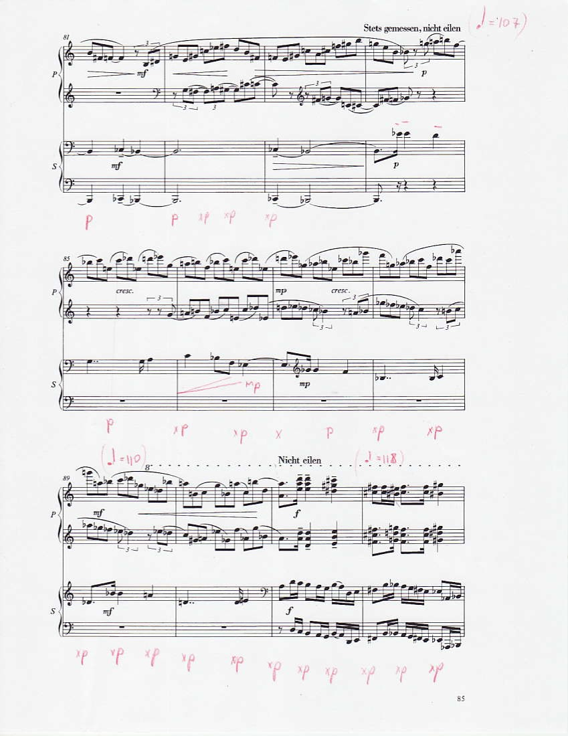
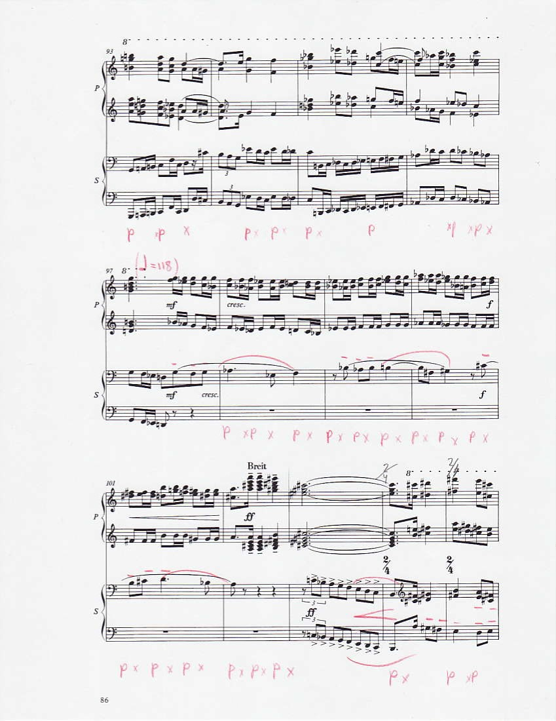
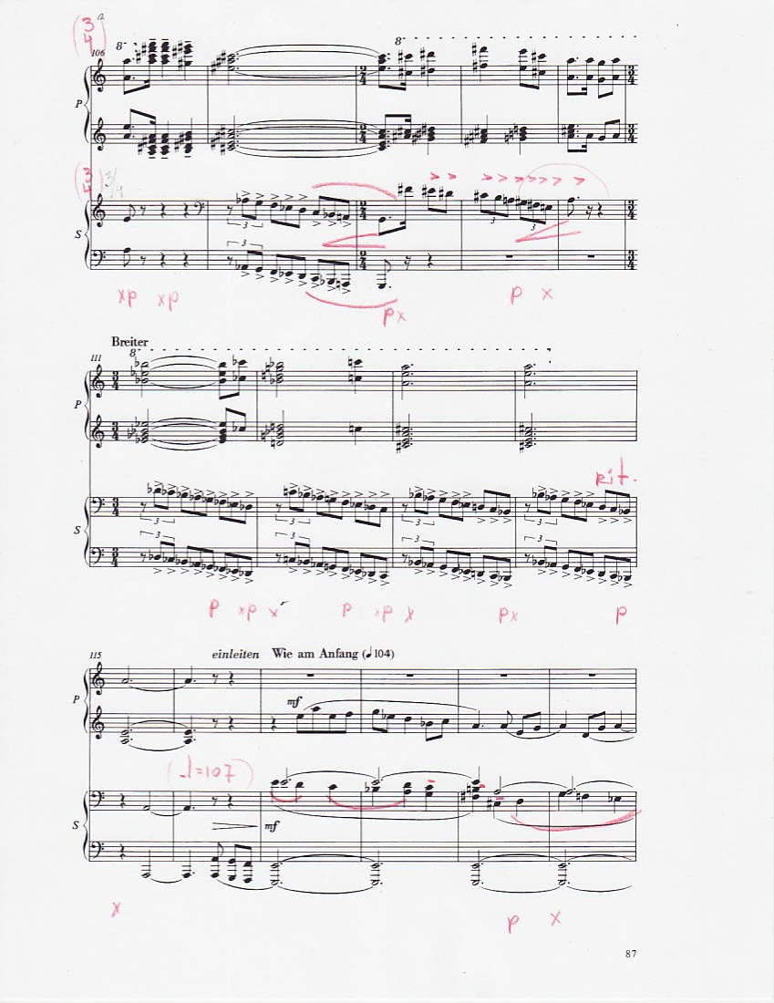

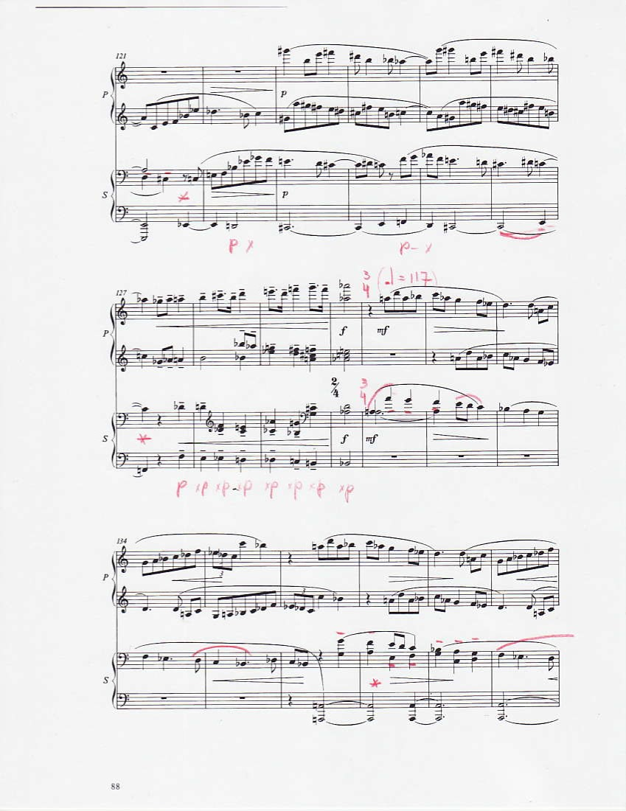

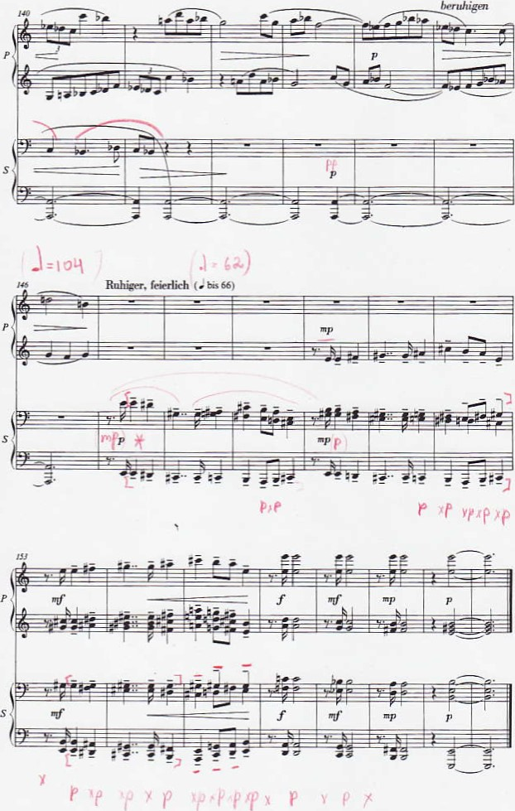
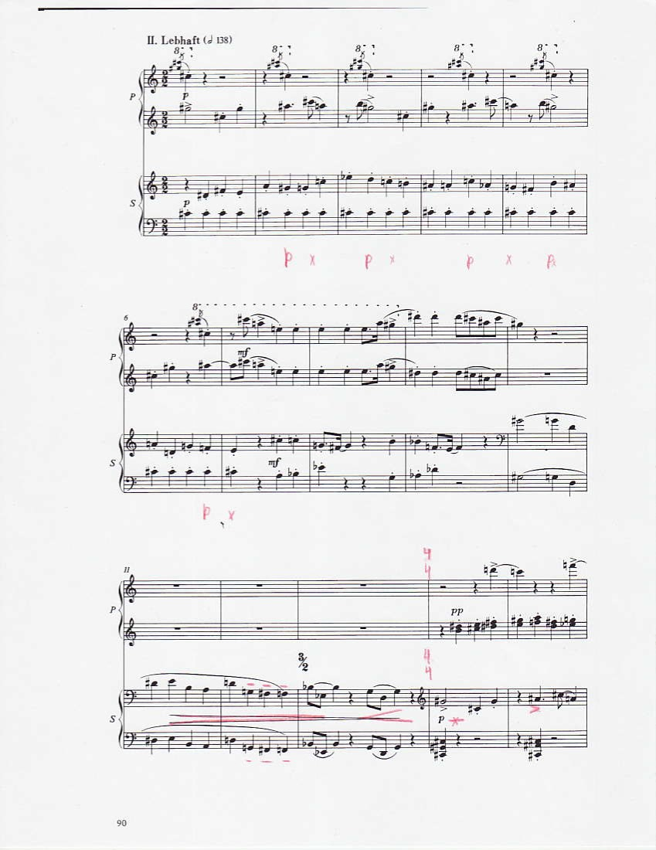

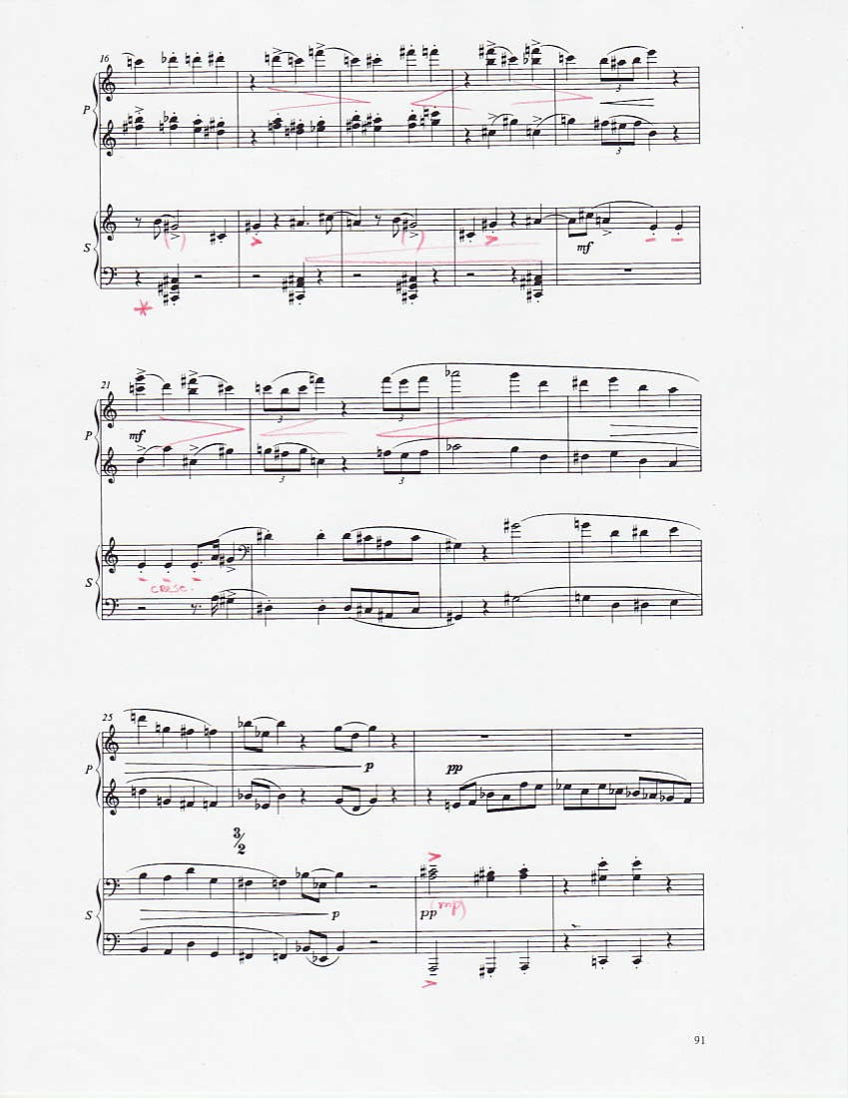
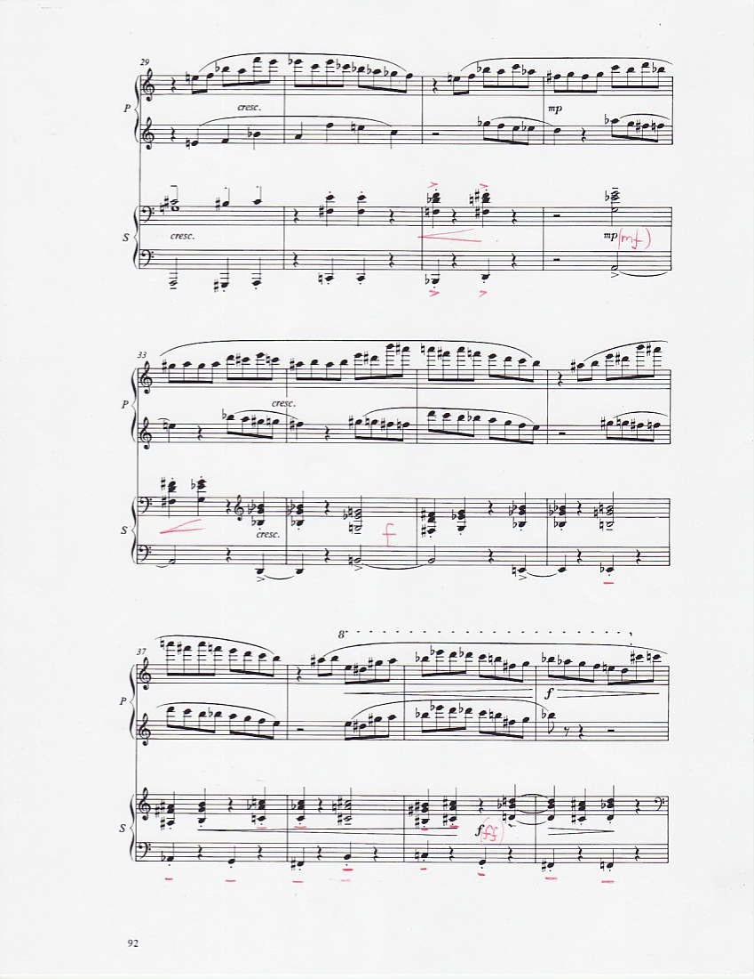

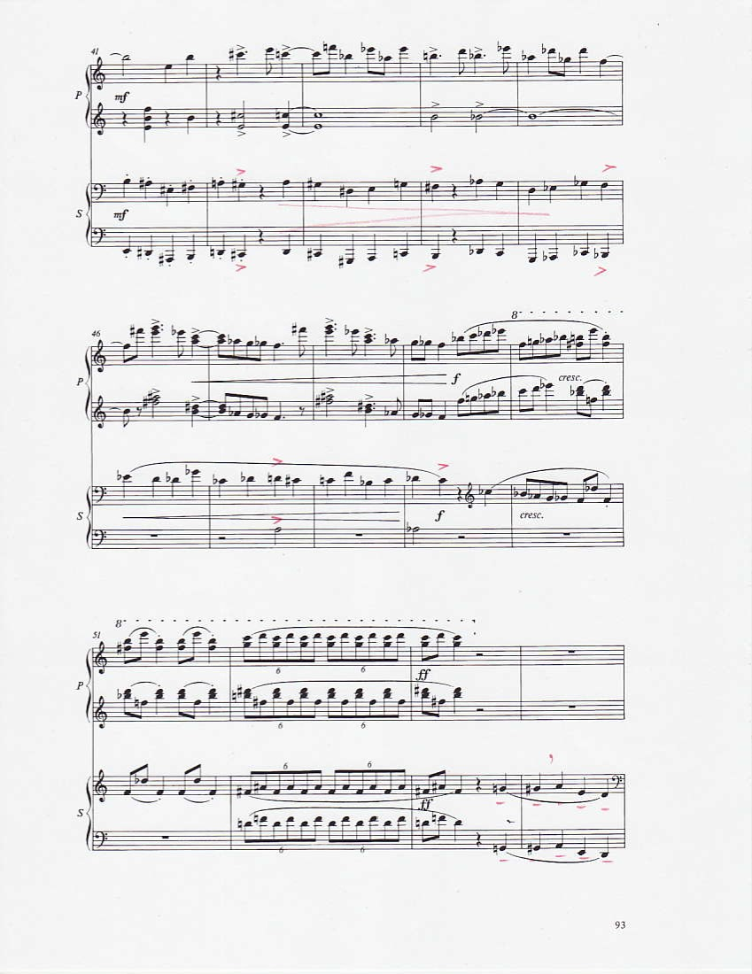

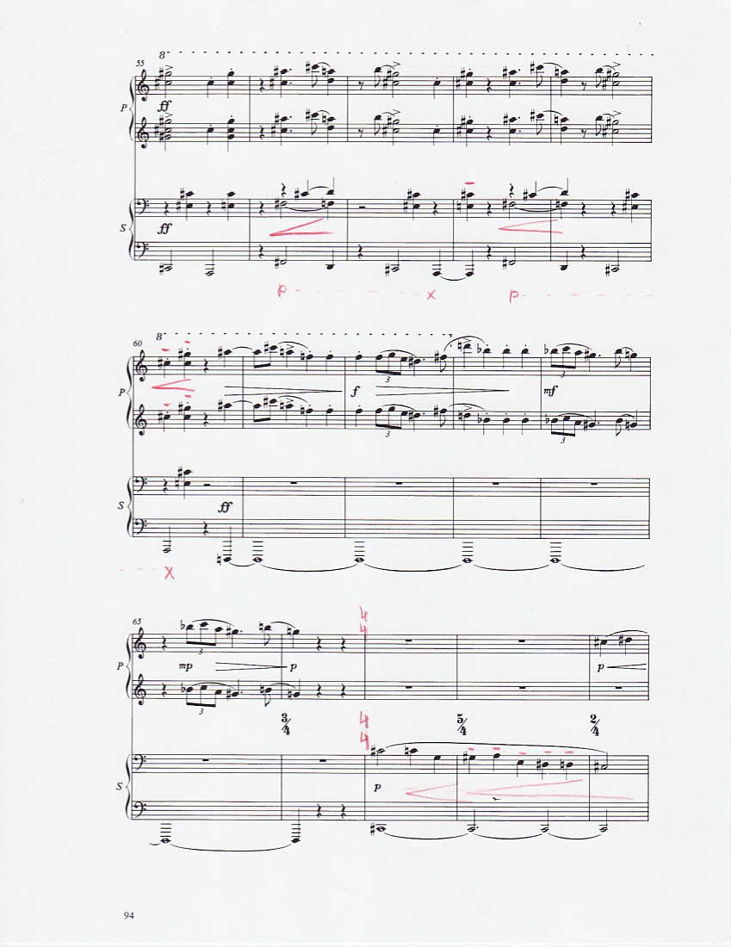

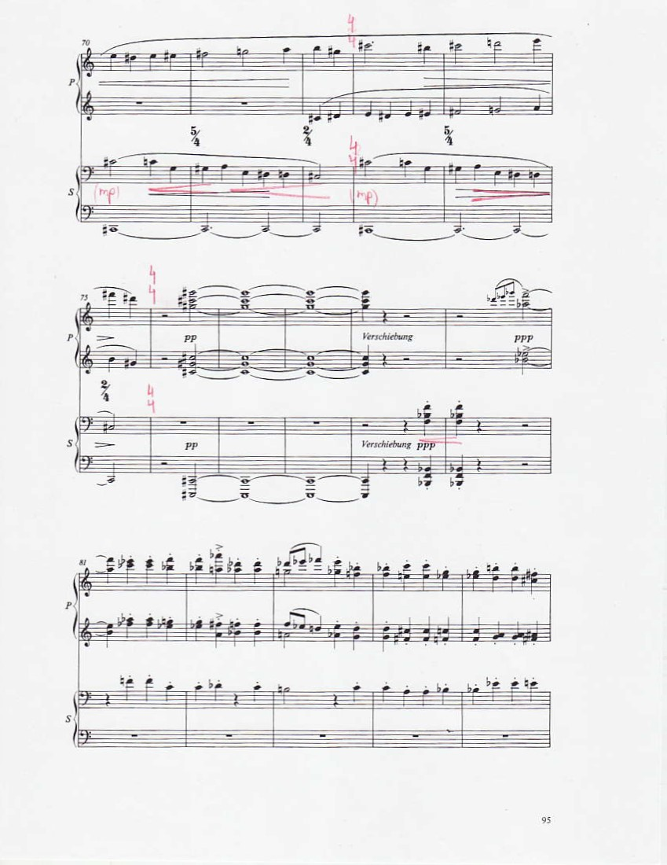

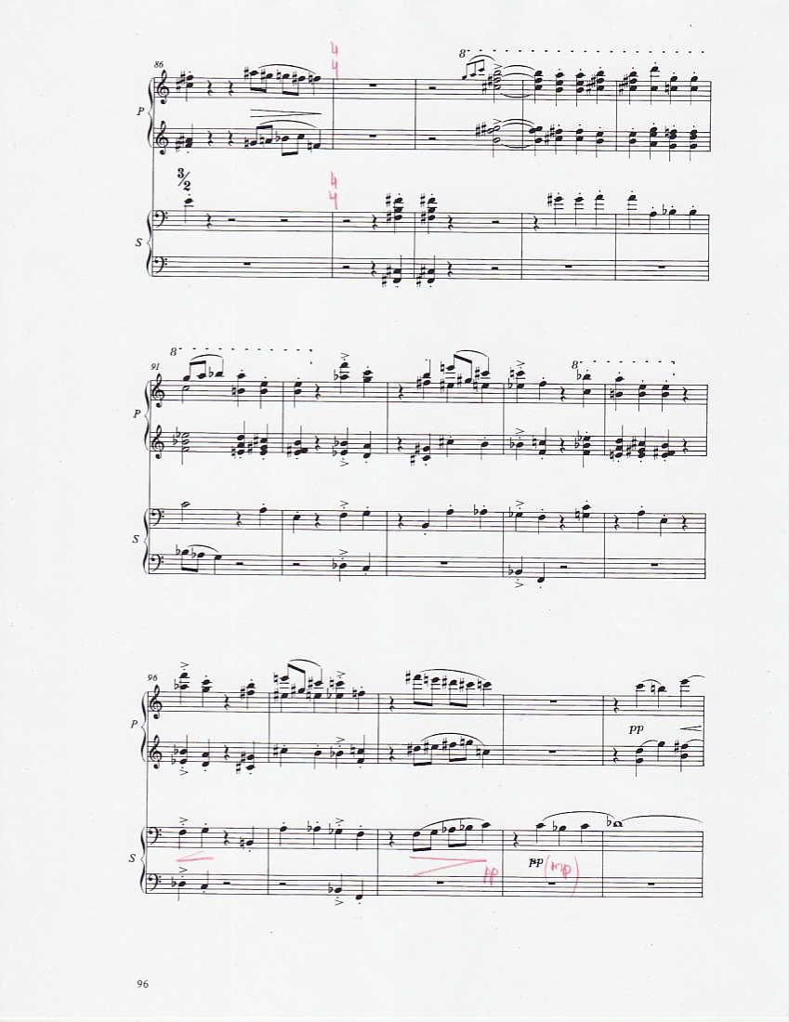
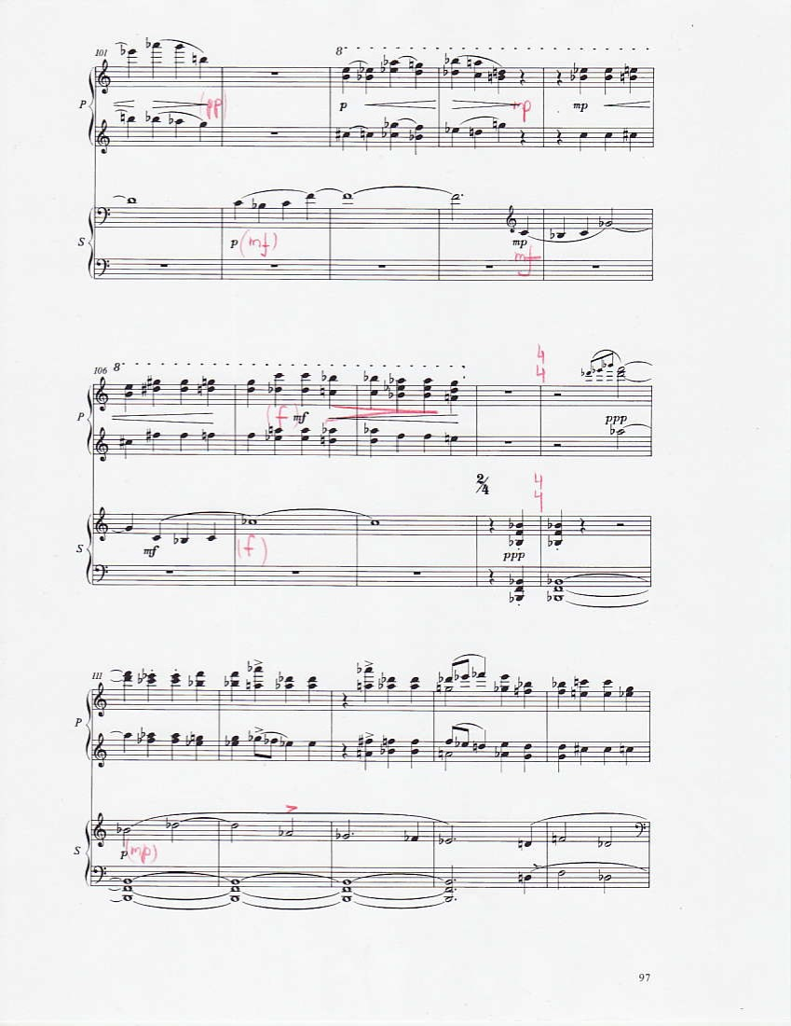

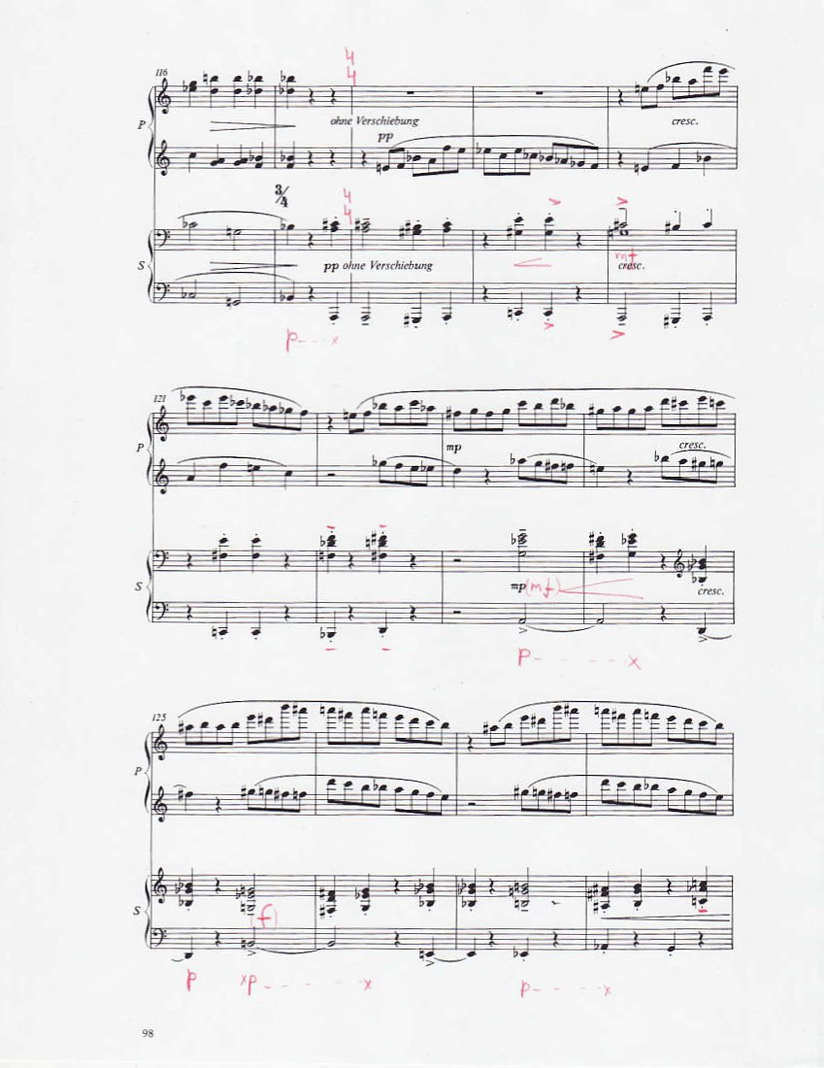
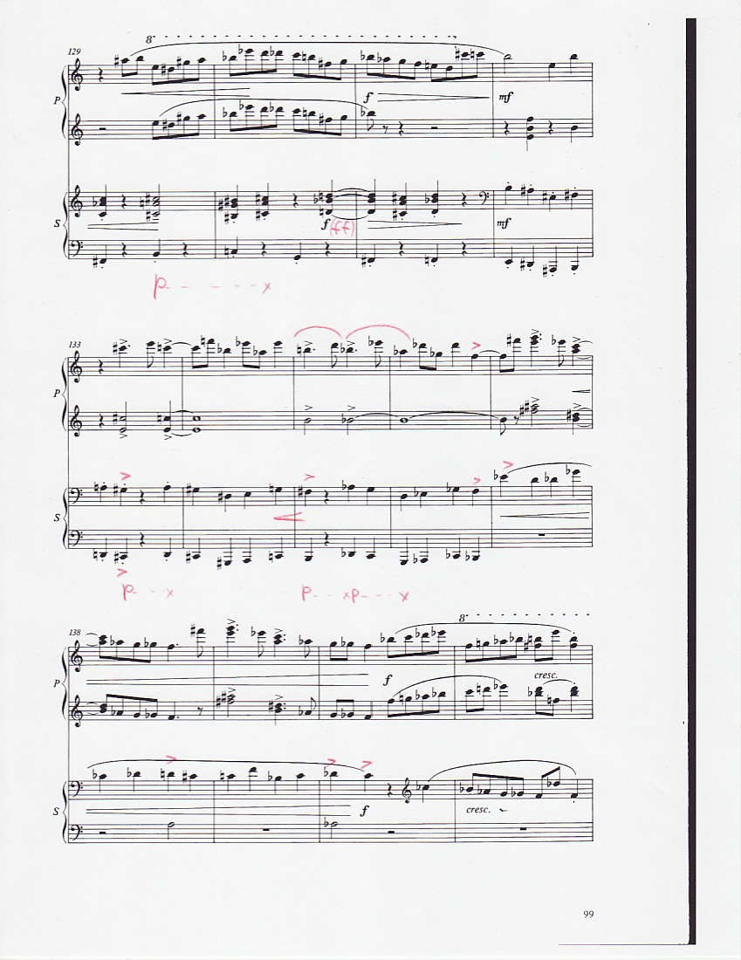

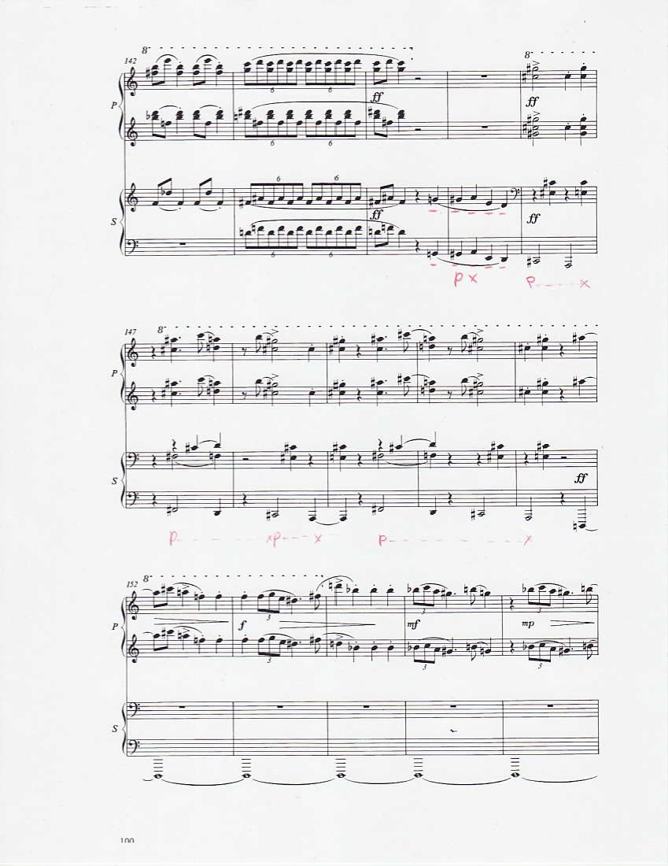
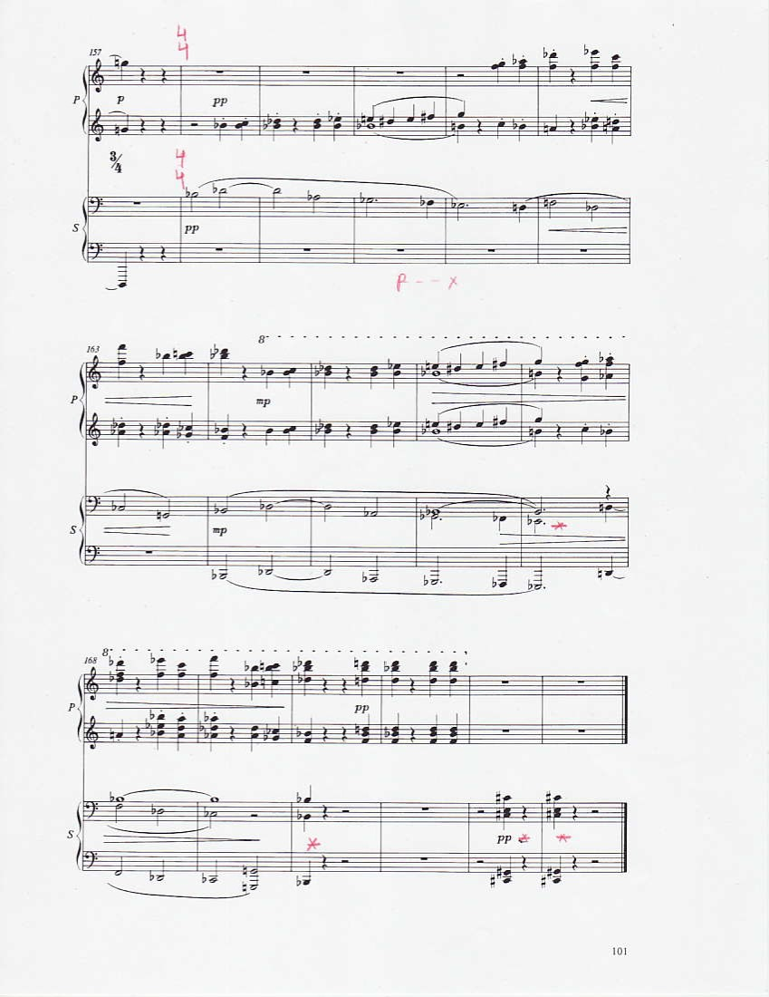

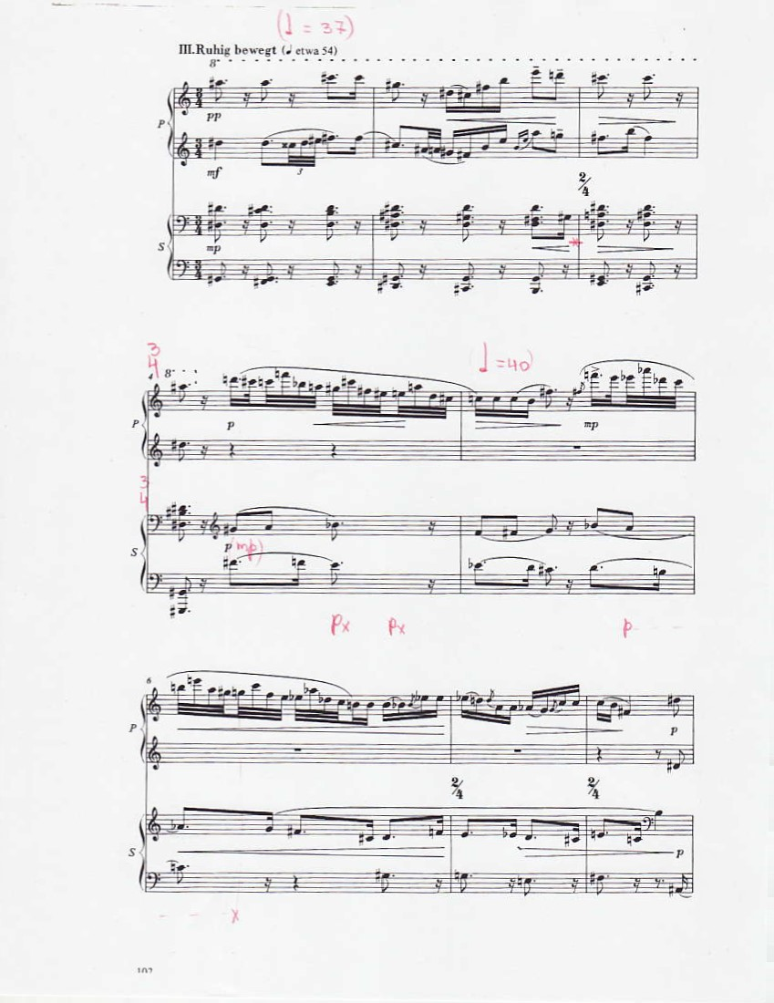

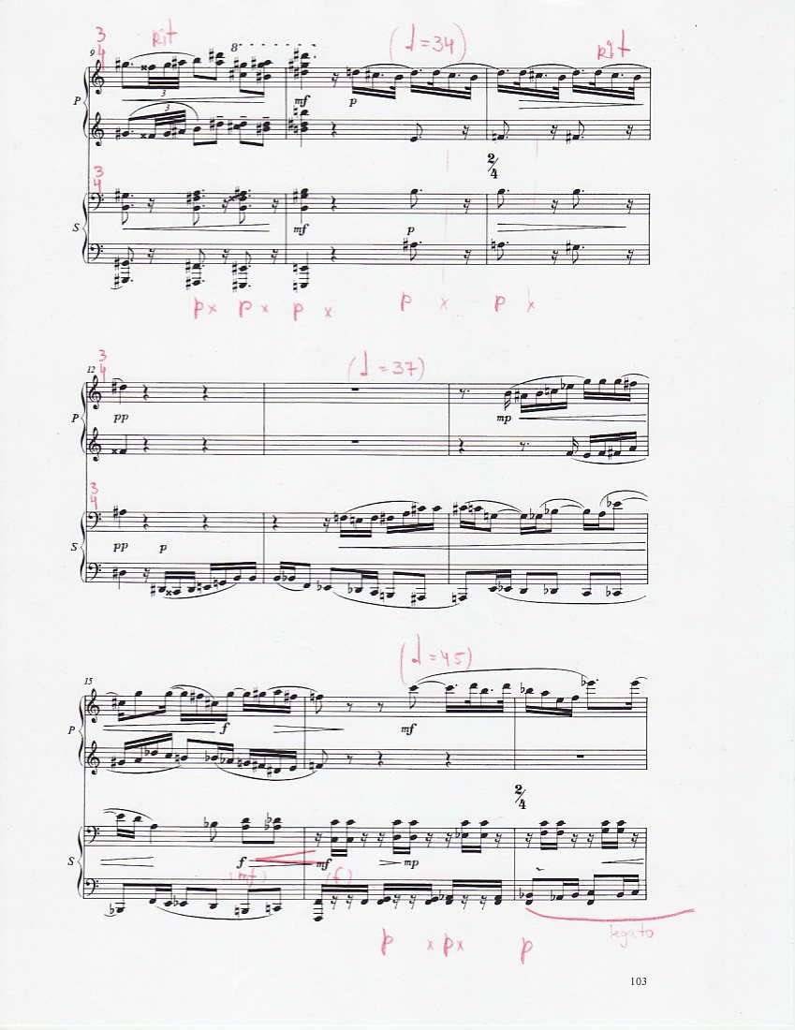
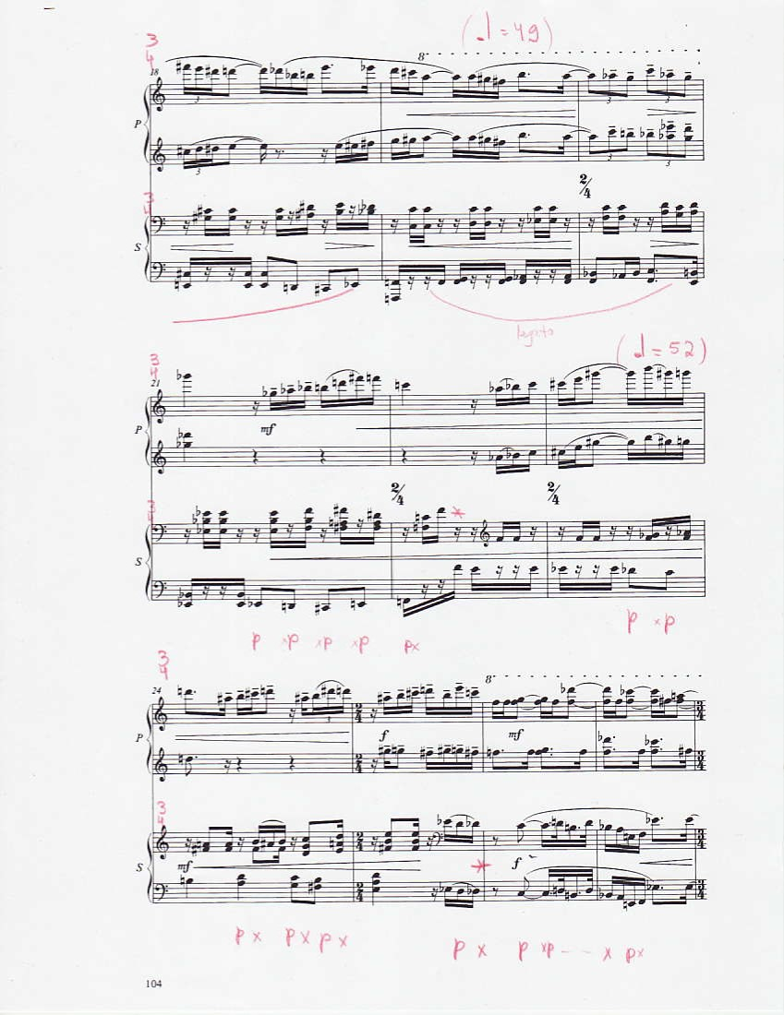

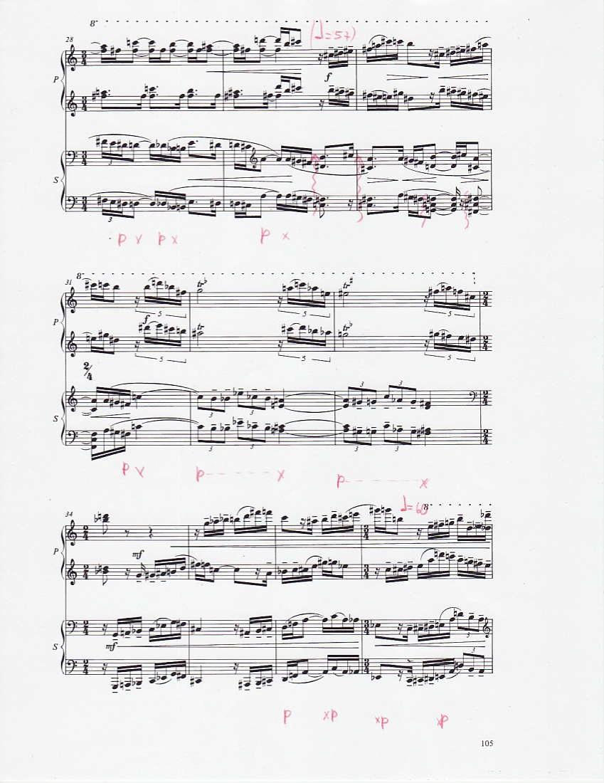
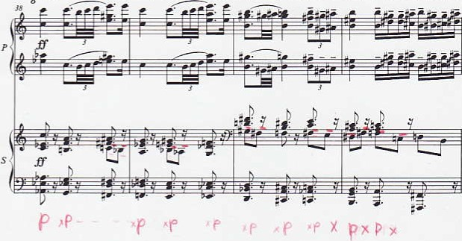
Sehr lebhaft (;• bis 152) aber 코라, ernst und gewichtig
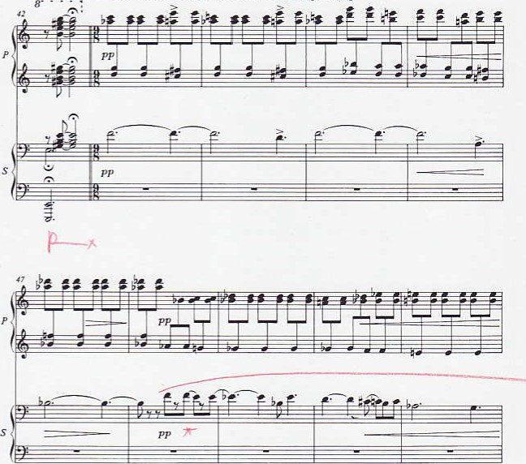

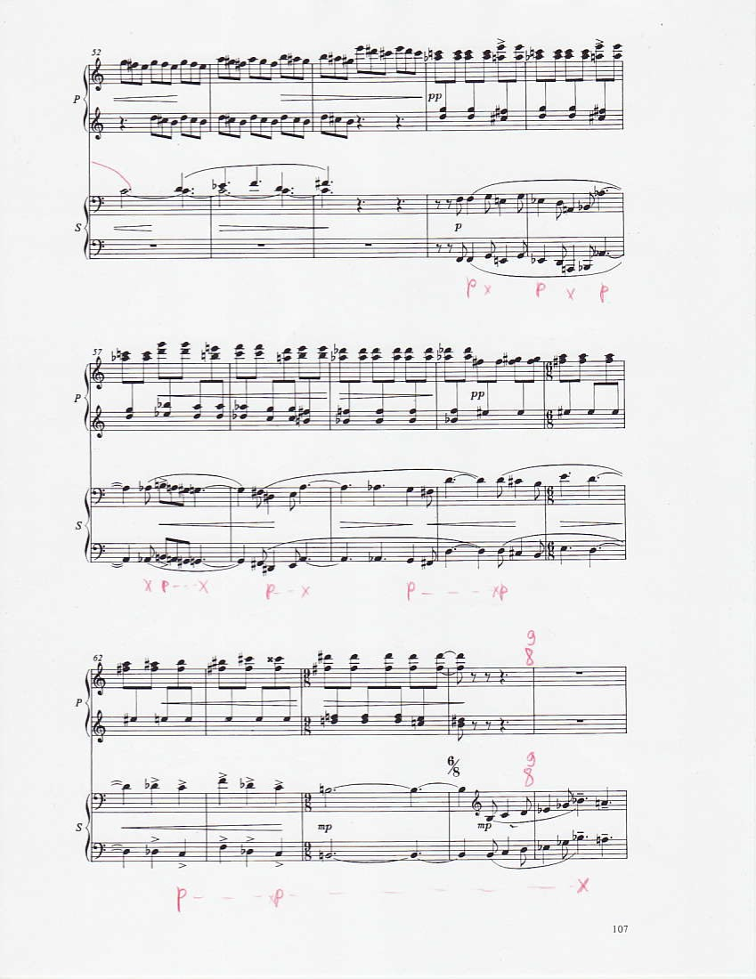

햫&%•켤류쯔특은
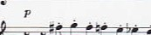
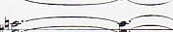
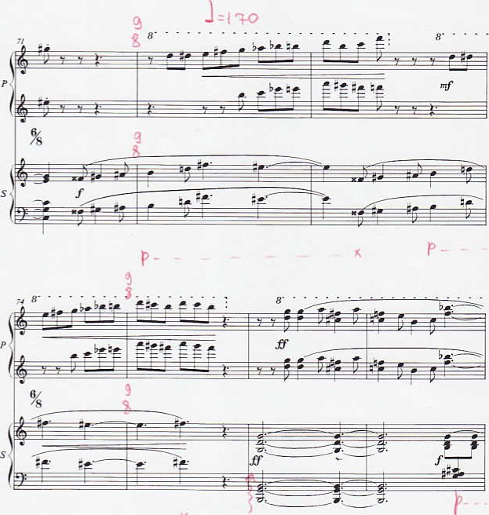

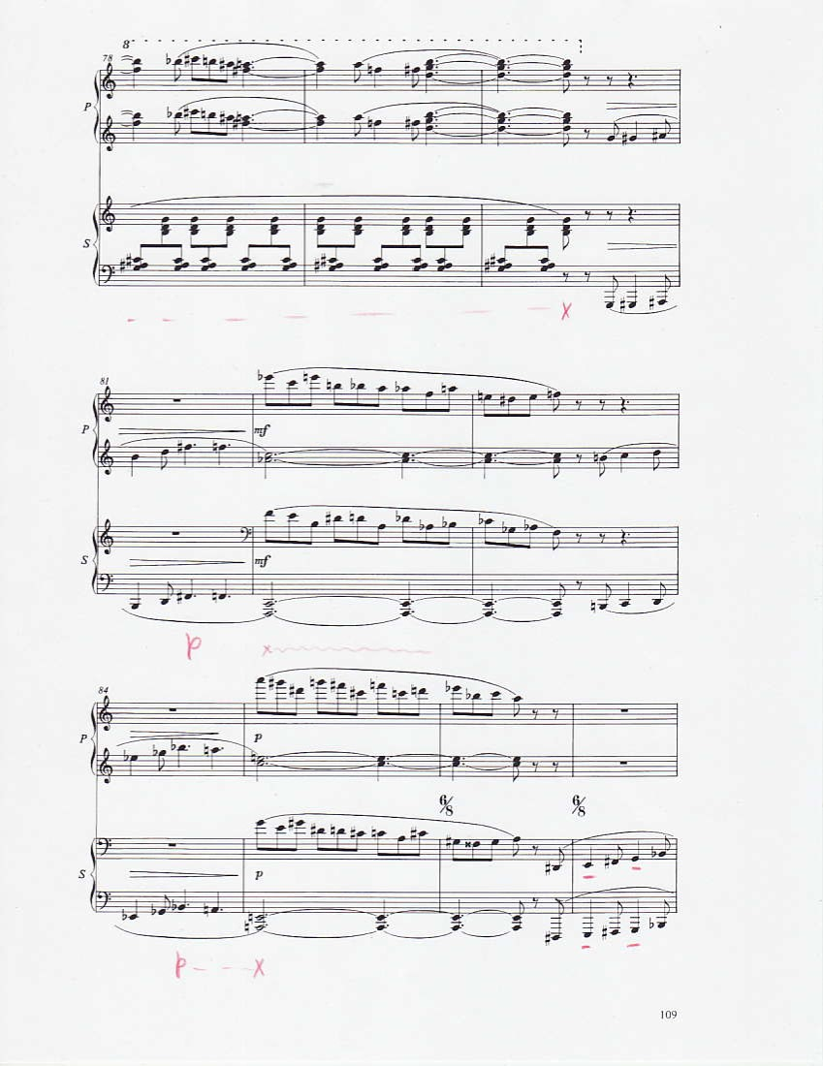

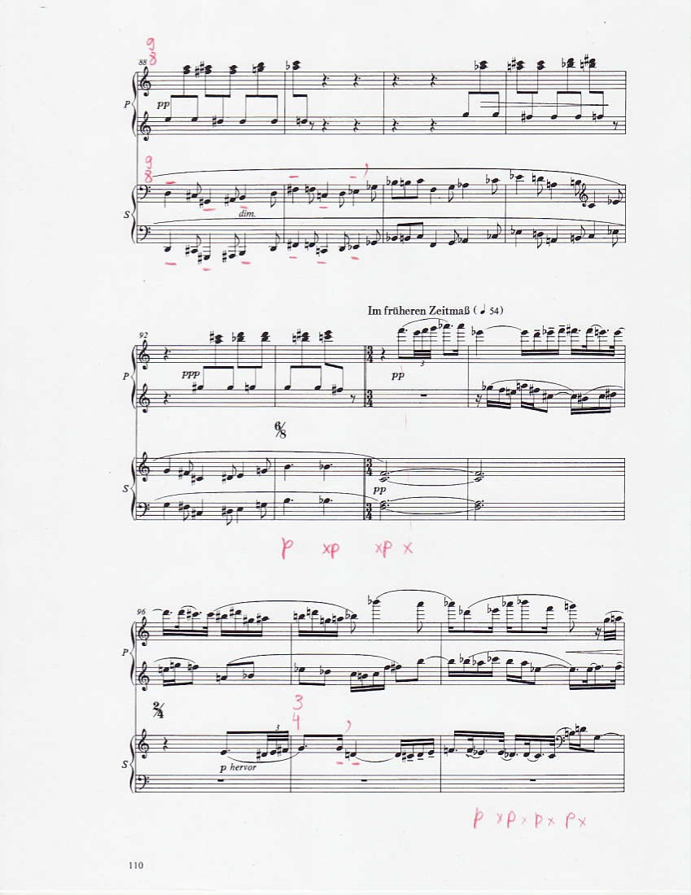
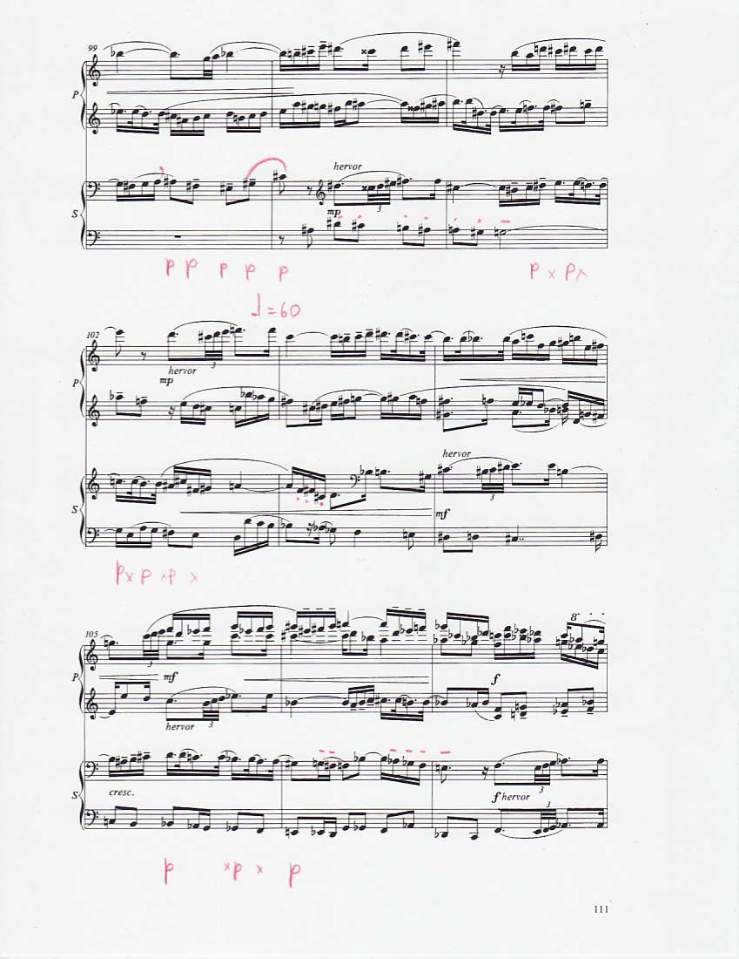

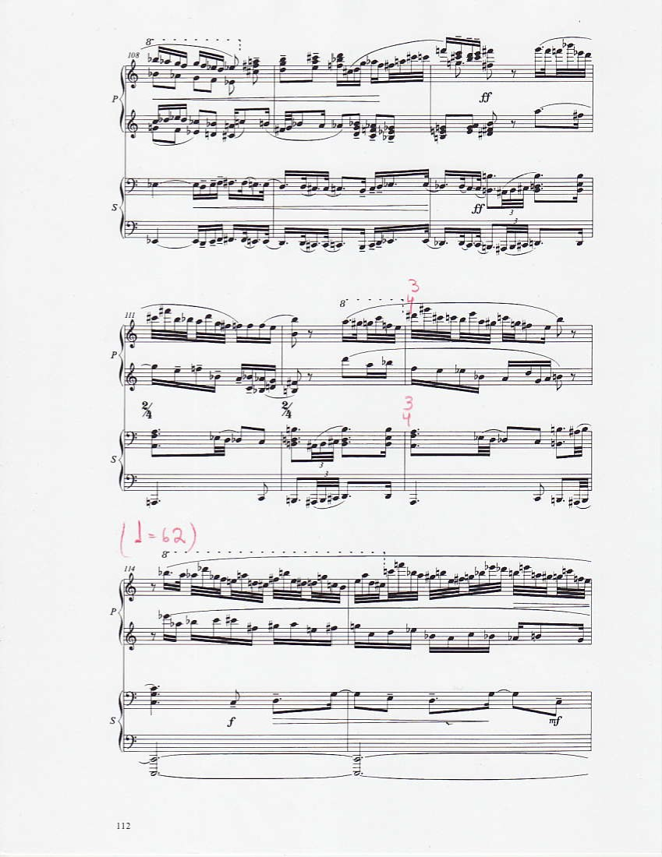

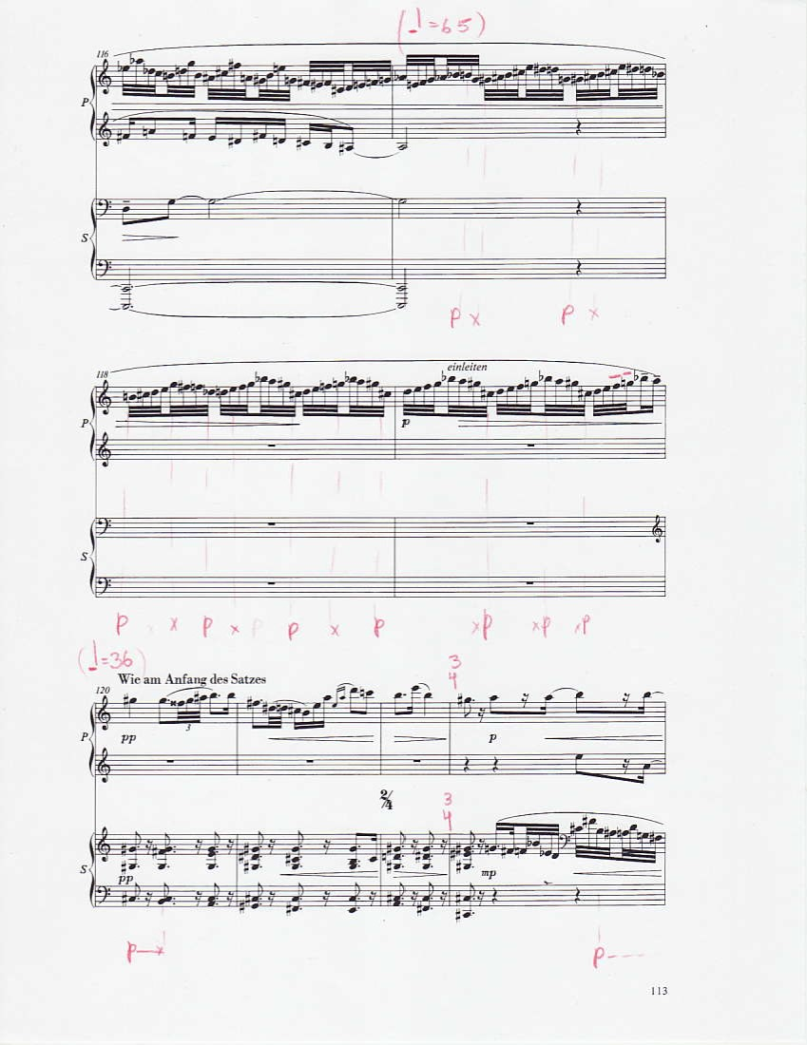
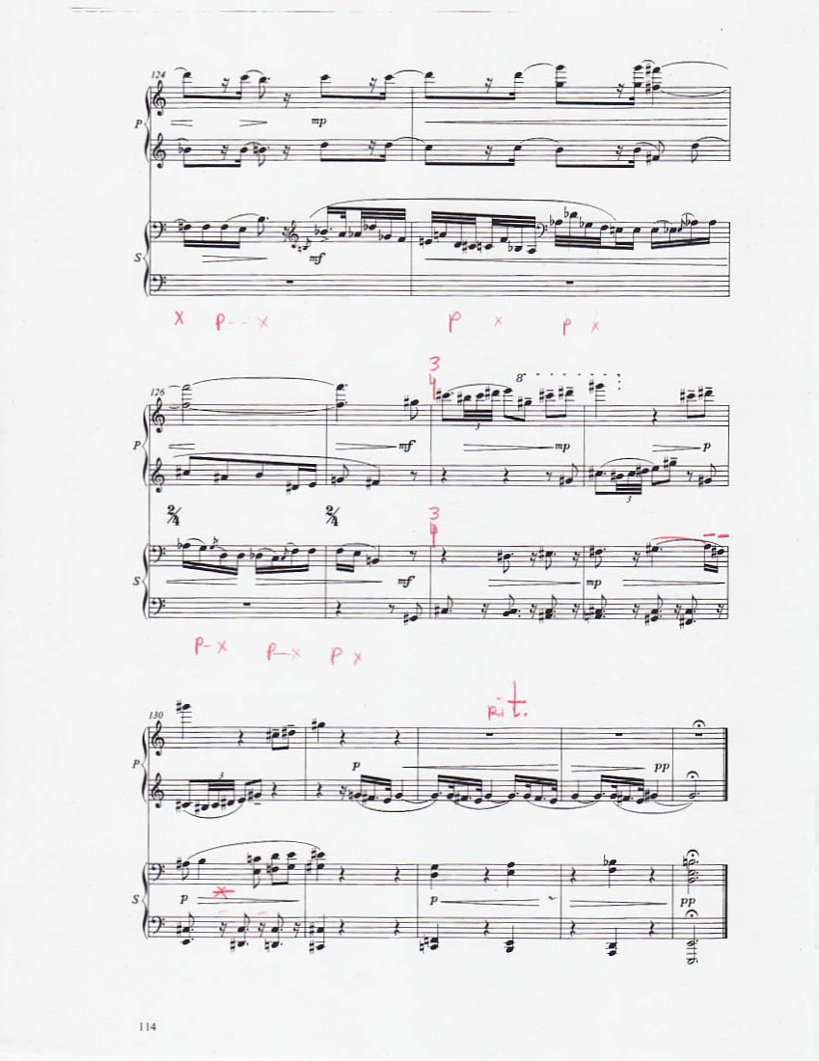

Edwin C. Powell, “An Interview with Keith Wilson on Hindemith’s ‘Symphonic Metamorphosis’,” Journal of Band Research 38 (2002): 37-48.
Arthur Reisman. Turkey's Modernization: Refugees from Nazism and Atatürk's Vision, (Washington, D.C: New Academia Publishing LLC, 2006), 88.
https://www.singers.com/composers/Paul-Hindemith/
Opera (June 1954): 348.
Paul Hindemith. A Composer’s Worlds: Horizons and Limitations (New York: Schott, 2000), 124.
Ibid.
Ibid.
Maurice Hinson, Guide to the Pianist’s Repertoire, 3rd ed. (Bloomington: Indiana University Press, 2001), 404.
Foundation Hindemith. “The Sonatas.” Accessed February 18, 2015, http://www.hindemith.info/en/life-work/biography/1933-1939/work/the-sonatas/
Katherine Schaeffer, “College Hears Noted German Musicians Play,” Vassar Miscellany News (Poughkeepsie, NY), March 4, 1939.
Luther Noss, Paul Hindemith in the United States (Champaign: University of Illinois Press, 1989), 54-55.
Paul Hindemith, “Sonata For Piano Four Hands,” recorded November 11, 1938. Compact disc.
Geoffrey Skelton, Selected Letters of Paul Hindemith (New Haven: Yale University Press, 1995), 111.
Noss, Paul Hindemith in the United States, 53-54.

