UNLOCKING THE PERFORMATIVE POTENTIAL OF  
SHOSTAKOVICH'S PIANO SONATA NO. 2

by

KSENIA ILINYKH

B.M., University of Utah, 2010

M.M., University of South Carolina, 2012

A dissertation submitted to the

Faculty of the Graduate School of the

University of Colorado in partial fulfillment

of the requirement for the degree of

Doctor of Musical Arts

College of Music

2017

This thesis entitled:

Unlocking the Performative Potential of Shostakovich's Piano Sonata No. 2

written by Ksenia Ilinykh

has been approved for the Piano and Keyboard Program

________________________________

Professor Andrew Cooperstock, Committee Chair

_________________________________

Professor Yonatan Malin, PhD

Date __________

The final copy of this thesis has been examined by the signatories, and we

find that both the content and the form meet acceptable presentation standards

of scholarly work in the above mentioned discipline.

Abstract

Ilinykh, Ksenia (D.M.A., Music, Piano Performance)

Unlocking the Performative Potential of Shostakovich's Piano Sonata No. 2

Dissertation directed by Associate Professor Yonatan Malin

Shostakovich’s Piano Sonata No. 2 occupies a unique place within the composer’s oeuvre. Written between the two world wars, his last piano sonata is centrally located within the timeline of the composer’s output. It also stands as a landmark of the composer’s style, and is often considered mandatory for pianists who hope to understand Shostakovich’s piano music. Nevertheless, it is infrequently performed, considered complicated and inaccessible. The writing is virtuosic without being pianistic, utilizes characteristically challenging twentieth-century Russian rhythmic devices, and features a peculiar melodic landscape that frequently jumps register. When it is performed, the second sonata often appears as part of cycles with titles such as “The Music of War and Victory,” “Russia in the World Wars,” and “Music of the Second World War.”

Perhaps the largest roadblock to a successful performance of the work is Shostakovich’s complex and idiosyncratic musical syntax. The syntactical complexity manifests itself in both the theoretical structure of the sonata and technical demands it places on the performer. In this analysis, I plan to explicate three requirements for a successful performance: understanding Shostakovich’s theoretical structures and composition devices, addressing unique pianistic technical concerns, and—perhaps most importantly—crafting an imaginative interpretation and mastering the phrasing of long, quintessentially Russian themes.

Dedication

To Raisa Ilinykh, Tatiana Ilinykh, and Scott Bair

Thank you so much for inspiring me and believing in me. For your example, love, encouragement and support.

I always will be grateful.

Acknowledgements

I am grateful for Professor Yonatan Malin, who provided mentoring of the thesis. In addition, I would like to extend my appreciation to the members of my Doctoral committee, including Professor Andrew Cooperstock, Professor Alejandro Cremaschi, Professor Mutsumi Moteki, Professor Laura Olson Osterman, for their guidance through my Doctoral pursuits.

I would not be where I am today without help of those teachers from my past. Thank you to Irina Vladimirovna, Olga Viktorovna and Marina Igorevna. I am blessed with encouraging and very supportive family and friends. Briawna Anderson, I am grateful for your friendship and our mutual love for music research.

**Contents**

Abstract iii

Dedication iv

Acknowledgements v

List of Figures viii

List of Examples ix

CHAPTER ONE INTRODUCTION: Why Russian Themes are Unique 1

Scope of Research 5

CHAPTER TWO: THEORETICAL AND TECHNICAL ANALYSIS 6

i. Theoretical Analysis: First Movement 6

1. Harmonic Foundations 7

2. Linear Analysis 11

2.A. The First Augmented Triad 12

2.B. The Second Augmented Triad 15

3. Deeper exploration of distant keys 17

ii. Theoretical Analysis: Second Movement 21

Section A 21

Section B 22

Section A¹ 22

iii. Theoretical Analysis: Third Movement 24

iv. Interpreting the Technical Requirements of Shostakovich's Piano Sonata No. 2 32

CHAPTER THREE: IMAGERY, PROGRAM, AND THE ART OF CRAFTING A PERFORMANCE 39

Methodology 39

i. Biographical sketches of Chekhov 45

1. Chekhov’s life and works 45

ii. Intersections between Shostakovich and Chekhov 48

"The Black Monk" 50

CHAPTER FOUR: Extramusical Inspirations for Shostakovich’s Second Piano Sonata 52

i. First Movement 52

ii. Second Movement 53

iii. Third Movement 55

CHAPTER FIVE: CONCLUSION 57

Bibliography 59

List of Figures

*Figure 1. Three progressions of alternate resolutions of nonadjacent triads*

*Figure 2. Map of potential key areas applied to the resolution of the first tritone*

*Figure 3. Map of potential key areas applied to the resolution of the second tritone*

*Figure 4. Map of potential key areas combined from the resolution of both triads*

*Figure 5. Map of key areas applied to the resolution of all three triads*

List of Examples

*Example 1. First Movement. Measures 1-3*

*Example 2. Primary Set: three minor triads derived from measures 1-3*

*Example 3. Primary Set in progression*

*Example 4. First Augmented Triad Derived from the Outline of the Roots of the Primary Set triads*

*Example 5. Outline of the top notes of the Primary Set*

*Example 6. The Second Augmented Triad, Derived Set.*

*Example 7. Resolution by a Semitone of the Primary Set*

*Example 8. Hexatonic Collection Derived from the Resolution by the Semitone of the Primary Set*

*Example 9. The first Augmented Triad and its Inversions*

*Example 10a. Enharmonic Equivalents of the First Augmented Triad (root)*

*Example 10b. Enharmonic Equivalent of the First Augmented Triad (first inversion)*

*Example 10c. Enharmonic Equivalent of the First Augmented Triad (second inversion)*

*Example 11a. Alternate resolutions of the First Augmented Triad and its Inversions. The Bass of the Triad and its inversions is the first scale degree of a major or minor.*

*Example 11b. Alternate resolutions of the First Augmented Triad and its Inversions. The Bass of the Triad and its inversions is the fifth of the major or minor.*

*Example 12. The Second Augmented Triad and its Inversions*

*Example 13a. Enharmonic Equivalents of the Second Augmented Triad (root)*

*Example 13b. Enharmonic Equivalents of the Second Augmented Triad (first inversion)*

*Example 13c. Enharmonic Equivalents of the Second Augmented Triad (second inversion*

*Example 14a. Alternate resolutions of the Second Augmented Triad and its Inversions. The Bass of the Triad and its inversions is the first scale degree of a major or minor.*

*Example 14b. Alternate resolutions of the Second Augmented Triad and its Inversions. The Bass of the Triad and its inversions is the fifth of a major or minor.*

*Example 15. Third Augmented Triad*

*Example 16. The Third Augmented Triad and its Inversions*

*Example 17a. Enharmonic Equivalents of the Third Augmented Triad (root)*

*Example 17b. Enharmonic Equivalents of the Third Augmented Triad (first inversion)*

*Example 17c. Enharmonic Equivalents of the Third Augmented Triad (second inversion)*

*Example 18a. Alternate resolutions of the Second Augmented Triad and its Inversions. The Bass of the Triad and its inversions is the first scale degree of a major or minor.*

*Example 18b. Alternate resolutions of the First Augmented Triad and its Inversions. The Bass of the Triad or its inversions is the fifth of the major or minor.*

*Example 19. Second Movement. Measures 1-3*

*Example 20. Allusions of "Mirages" Through the Arpeggiated Passages in the Final Part of the Second Movement*

*Example 21. Another Type of "Mirages" in the Final Part of the Second Movement*

*Example 22. Chromatic Motives of the Opening in the Third Movement*

*Example 23. Outline of the Six Lament-like Motives in the Opening of the Third Movement*

*Example 24. D-S-C-H motive cryptogram'*

*Example 25. Variants of the D-S-C-H motive*

*Example 26. Further Related Variants of the D-S-C-H motive*

*Example 27. B-A-C-H Cryptogram*

*Example 28. Suggestions on the Expressive Interpretation of the first Thirty Measures of the Third Movement's Opening*

*Example 29. Possibility of Registeral Prolongation through the Replay of the Bass*

*Example 30. An Added Arpeggiation to the Top two Voices to Emphasize Theme in the F sharp major Fugue from the Op. 87*

*Example 31. Possible Adding of the Arpeggiation to the Opening of the Third Movement*

CHAPTER ONE   
INTRODUCTION: Why Russian Themes are Unique

Shostakovich’s Second Sonata is among his least popular works for the piano. It is a deeply introspective and opaque piece of music, and presents numerous challenges to the performer, both technical and interpretive. The sonata features virtuosic writing that is not pianistic, utilizes characteristically challenging twentieth-century Russian rhythmic devices, and features a peculiar melodic landscape that frequently jumps register. Themes and motives within the sonata are often lengthy and asymmetrical, making phrasing a challenge for even skilled performers.

One explanation for the challenging and unpianistic features of the sonata is that Shostakovich’s compositional style often mirrors Russian linguistic patterns. As a native Russian speaker, I can attest to the fact that the Russian language lends itself quite naturally to complex sentences with long descriptive passages. The research of neuroscientists A. D. Patel and J. R. Daniele claims that “music reflects linguistic prosody” and analyzes the connection between a composer’s native tongue and their musical style:

It is known from studies of language acquisition that the perceptual system is sensitive to the rhythmic patterns of language from a very early age (Nazzi et al., 1998; Ramus, 2002a). Composers, like other members of their culture, internalize these patterns as part of learning to speak their native language. One explanation suggests that when composers write music, linguistic rhythms are “in their ears”, and they can consciously or unconsciously draw on these patterns in weaving the sonic fabric of their music.[1]

While Patel and Daniele are among the first to explore the scientific proof behind a linguistic-musical connection, the concept has been investigated before by both musicologists and linguists alike. Nicholas Temperley and David Temperley surmise that “there are correlations between language and musical style across cultures or nations—that is, that the music of a nation tends to resemble its language in some way.”[2] Gerald Abraham asserts that “the nature of a people’s language inevitably affects the nature of its music not only in the obvious and superficial ways but fundamentally.”[3]

However, this dissertation does not attempt to provide the reader with an extensive analysis of Russian language syntax. Such a feat would be beyond the scope of a document of this length, and would require that the reader be well-studied in Russian grammar first. Instead, a more accessible approach is undertaken here, based on three areas of analysis: theoretical, technical, and interpretive. The expediency of the first two is self-explanatory; any successful performance requires a robust understanding of the theoretical structure of the work, as well as the unique technical requirements. It is in the final area of analysis that I offer a unique approach. Where a complete understanding of Russian syntax is not prudent, a comparative analysis of Russian literature, alongside certain works of Russian composers, can offer key insights for a performer’s interpretation.

Russian piano pedagogues often employ imagery to inspire the pupil. This approach is analogous to Russian literary styles, in which mood, setting, and characters often take precedence over an action-filled plot. Because of the important link between Russian literary and musical styles, I began looking for linguistic and musical connections that could fuel a more robust performance of Shostakovich’s challenging final piano sonata.

Russian literature, even in translation, is a product of the unique linguistic structure of the Russian language, and bears out many of its idiosyncrasies. A study of select examples of Russian literature *can* offer English-speaking performers a glimpse into the linguistic and thought patterns of native Russian speakers, which are distinct from those whose mother tongue is either Germanic or Latin-based. A good translation will preserve the unique quality of Russian writing.

Rosamund Bartlett, considered one of the best interdisciplinary scholars within Russian music and literature studies, explains the difficulties of translating Russian literature in an interview with *Russia Beyond*:

Tolstoy is generally very difficult to translate, although he is probably the easier writer to read. He is incredibly challenging, because he writes in such a clear and natural way, using simple, conversational Russian, but he also breaks all the rules of good syntax, as usual rebelling against conventions—as he did in nearly every other aspect of his life.

You often encounter enormously long sentences packed with subordinate clauses, long strings of adjectives, and dense clusters of participles and gerunds, plus a deliberate use of repetition, all of which is hard to convey naturally in English.[4]

It was in my reading of Bartlett’s analysis[5] that I first recognized a distinct historical literary connection in Shostakovich’s Piano Sonata No. 2.

Bartlett references the recollections of Solomon Volkov, Shostakovich’s contemporary, in which Volkov recounts the composer’s opinion that Anton Chekhov’s short story “The Black Monk” was written in sonata form.[6] Shostakovich made similar comments in an article in 1943, the same year in which his Piano Sonata No. 2 was written.[7] The concurrency of the composer’s observation and the composition of his sonata suggest that Chekhov’s story was on Shostakovich’s mind as he wrote this unique solo work.

As I proceeded with my own attempt to craft an imaginative and dynamic performance of the Second Piano Sonata, I found myself drawn to the story of “The Black Monk” and found many useful parallels between the two. Assigning a literal program to an abstract piece of music ventures into dangerous academic territory. However, there is merit for the performer in identifying extramusical associations and sources of imagery that can help him or her to develop a kinesthetic approach to the piece and organize it into a cohesive narrative.

For me, this process seemed not only utilitarian, but expedient. The characters of the work appeared vivid and distinct in my mind. The progression of the sonata seemed to imply a story, one that—if mapped out in my imagination—gave my performance vigor and depth. However, there need be no transmission of such a narrative to the audience. In this case, the program is not an explanation for the work—which itself requires no explanation or introduction—but rather a tool for crafting a fine performance. I argue that Chekhov’s story “The Black Monk” can serve as a valuable external program to Shostakovich’s Second Piano Sonata, providing the performer with a framework to better approach an otherwise opaque work. In my own performance of the Second Sonata, an analysis of “The Black Monk” infused my playing with vitality, imagery, and unique phrasing that would not have been possible had the work been approached solely on abstract grounds.

For a performer to understand Shostakovich’s Piano Sonata No. 2 without an exhaustive study of the Russian language (such that the composer’s syntax becomes intuitive for the pianist), the theoretical framework behind the work must be examined in musical terms. The musical grammar and syntax of the sonata are deeply linked with Shostakovich’s native language, and therefore some attempt to understand this connection is vital in capturing the imagery and semantics of the piece. Often, the utility behind Russian authors’ use of lengthy descriptive passages and deliberate repetition lies in its expression of the Russian ethos as being experiential, sensory, and process-oriented. To put it another way: the language is a reflection of the culture of Russian peoples; in essence, it is the distillation of the “Russian Soul.” This same cultural expression is evident in the music of Shostakovich as well. From his long, rambling melodies that mirror Chekhov’s descriptive sentences, to his dense harmonic rhythm, Shostakovich’s writing demands an attentive and focused performance.

Scope of Research

No amount of imagery or programmatic inspiration is useful without a firm grasp of the theoretical framework of a piece. Thus, prior to exploring the extramusical connections that aided the creation of my own performance, I will first undertake a theoretical analysis that examines key elements of musical syntax and construction. In each movement, I have selected a principle theoretical element on which to focus. These elements, rather than serving solely sterile academic interests, tie directly into the programmatic analysis that follows. In a brief following section, I have addressed a number of technical concerns unique to this piece that must be carefully approached by the pianist.

In this paper’s second half, I will deconstruct the story of “The Black Monk” and explain how it can serve as a springboard for a performer’s comprehension of Shostakovich’s Piano Sonata No. 2, making the complex theoretical design more palatable. First, I will offer a brief biographical sketch of both the composer and the author, and explain their connection. Following that exposition, I will deliver a synopsis of Chekhov’s story before launching into an analysis of how the literary program can provide useful imagery for crafting a creative performance of Shostakovich’s Second Sonata.

CHAPTER TWO: THEORETICAL AND TECHNICAL ANALYSIS

i. Theoretical Analysis: First Movement

Shostakovich’s opening is unique on several accounts. It commences with a single line melody that is highly chromatic in nature. The intensity of this opening material is increased by the fact that the first notation is a rest, rather than a note, creating a breathless and spontaneous sensation that is immediately furthered by the rapid sixteenth notes that follow. Amid this frenetic blur of rapid figuration, three notes emerge, accented by the left hand, and spelling out an augmented triad. Within the first three measures, the essential drama of the movement is established: chromatic passages are juxtaposed with the triadic motives.

In my harmonic analysis of the first movement, and particularly of the introductory motive, I am guided by Richard’s Cohn transformational theory of the triads that analyzes harmonic complexities of the triadic progression. In his research[8], alternative triadic syntax leads to a different view of interrelationship of one triad to another, directing to a new way of perceiving and interpreting composed music. As shown in the *Figure 1*, a triad could relate to another triad by a common tone or could reach it with a semifinal motion. According to Cohn, these relations are ambivalent, as they “depict sublime, supernatural, or exotic phenomena,”[9] and lead to symbolic associations of life and death, reality and illusions.

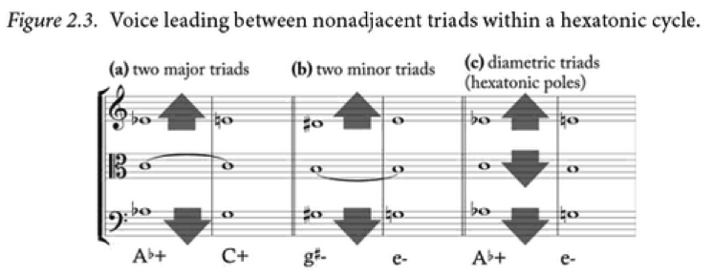

Figure 1. Three Progressions of Alternate Resolutions of Nonadjacent Triads

In the theoretical analysis of the first movement, I present a series of three augmented triads and using Cohn methodology of alternate triad resolutions, I show how they relate to other nonadjacent major and minor triads by smooth voice-leading.

1. Harmonic Foundations

The motivic landscape of the opening motive has an ambiguous tonal quality. The first three notes of the sonata spell a B minor triad in first inversion (*Example 1*). Two subsequent first-inversion triads follow, each beginning on the separated left-hand notes of B-flat and F-sharp, respectively.

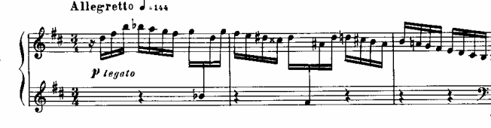

Example 1. First Movement. Measures 1-3

What we end up with at first glance is a set of three minor triads: B minor, G minor, and D-sharp minor, as shown in *Example 2*:

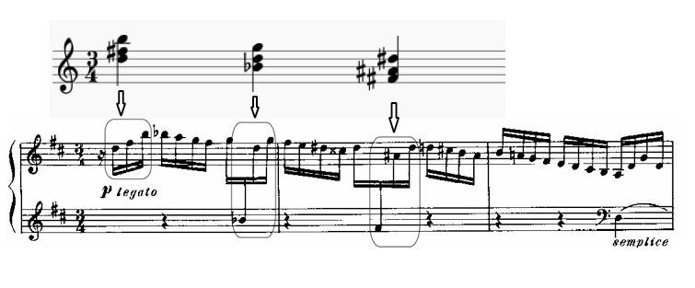

Example 2. Primary Set: three minor triads derived from measures 1-3

These three chords comprise what I call the “primary set,” and are the foundation of this post-tonal work’s harmonic structure, in much the same way as the primary triads of a standard progression in Classical tonality. *Example 3* presents the primary set (which first appeared in first inversion) in their root positions, allowing us to better see their progression and the larger scheme they outline:

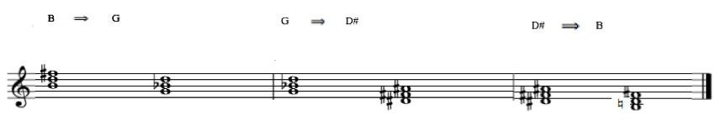

Example 3. Primary Set in progression

At first glance, these triads seem unrelated, however, when we analyze the relationship between them, a deeper structure is unveiled. The roots of these triads outline an augmented triad: G – B – D-sharp (*Example 4*).

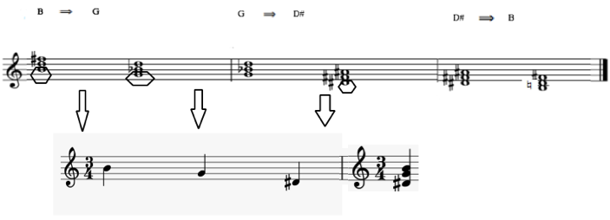

Example 4. First Augmented Triad Derived from the Outline of the roots of the Primary Set triads

This triad also emerges from the top notes of the melodic line of the introductory motive, further emphasizing its importance (*Example 5*):

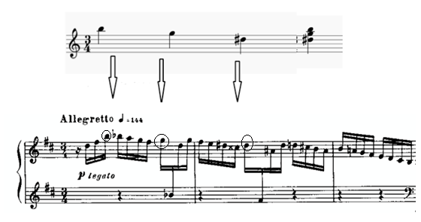

Example 5. Outline of the top notes of the Primary Set

A second augmented triad can also be derived from the primary set, by taking the third of each chord: D – B-flat – F-sharp. This augmented triad is emphasized in the left hand, where the lower voice stands out from the peripheral chromatic passage, as outlined in square boxes in *Example 6*. These notes occupy a lower register than their surrounding counterparts and are uniquely stemmed to clearly indicate to the performer that they be treated as separate from the sixteenth notes above them.

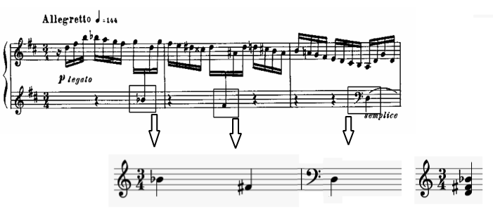

Example 6. The second Augmented Triad, Derived Set

Each of these two augmented triadic constructions (and the tonal ambiguity from which they are derived) becomes an important harmonic component of the music that develops. Going forward, I will refer to these as the “derived set.” At first glance (or first listen), the triads outlined in this introductory motive seem so distantly related that they might be considered random, or without harmonic functionality. Certainly, the harmonic progression laid out by Shostakovich is far from what one expects in traditional sonata form. (In fact, the biggest argument for abandoning any use of sonata form in the analysis of this piece is its lack of tonic-dominant relationships.) However, rather than being random flights of harmonic fancy or purely melodic devices, these triads are part of a larger harmonic scheme, rooted in triadic post-tonality. These triads, together with their chromatic background, form the linear head motive of the piece, which I will hereafter call the Introductory Theme. This Introductory Theme appears throughout the movement and foreshadows main points of arrival, such as the Secondary Theme and the recapitulation.

Unlike contemporary works of the Second Viennese School, Shostakovich’s Second Piano Sonata does not embrace serialism, but rather, occupies a space between traditional tonality and the liberation of post-tonal theoretical ideas. As William Hussey explains:

Music analysts in the west tend to place composers harmonically into one of two categories, tonal or atonal, which leaves little room for those that fall somewhere in between. When a musical work does not clearly fit into one of these classifications, the difficulties in applying an analytical system can seem insurmountable.[10]

It becomes evident at this point that triadic constructions are the foundation of this Introductory Theme. These triads (the “primary set” comprised of three minor triads in first inversion and the “derived set” of two augmented triads) are embedded in a chromatic background that, in and of itself, reinforces the strong relationships between these triads.

2. Linear Analysis

My initial analysis of the Introductory Theme involved a vertical approach; however, this next section will investigate the linear direction of the accompanimental filigree. *Example 7* shows how the root of each triad in the primary set resolves down by a semitone. This chromaticism lends a frantic, restive feeling to the rapid melodic line. However, it serves a double purpose in reinforcing the two augmented triads of the derived set as well.

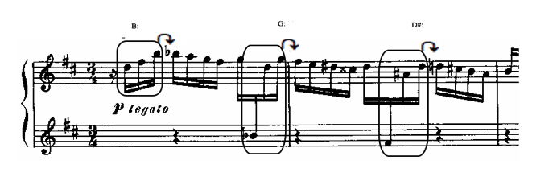

Example 7. Resolution by a Semitone of the Primary Set

These resolutions comprise three semitonal pairs: B → B-flat, G → F-sharp, and D-sharp → D, which construct a hexatonic collection, as shown in *Example 8*:

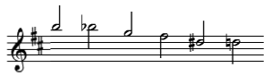

Example 8. Hexatonic Collection Derived from the Resolution by Semitone of the Primary Set

Upon further inspection, we see that this hexatonic collection, built from the resolutions of the primary set of triads, contains the two augmented triads of the derived set: B – G – D-sharp and B-flat – F-sharp – D. The formation of these triads through both vertical harmonic and horizontal chromatic means is the most important aspect of the head-motive, because it displaces the governing authority of our tonic key (B minor). Instead, the piece privileges the exploration of all triads equally. This, of course, is philosophically connected to the theory of free-tonality or 12-tone serialism, in that the harmonic function of a governing tonic is discarded. However, it differs dramatically from its Second Viennese counterparts in its retention of the triad as a governing and essential musical principle. Triads, and their various modalities, are still the building blocks of this music. Their functions, however, are rewritten. This is at the heart of Triadic Post Tonality.

2.A. The First Augmented Triad

As previewed earlier, I will now apply Cohn’s method of reaching to the distant keys by chordal voice-leading and use of common tones to demonstrate how the many alternate resolutions for augmented triads allow exploration of many key areas, both close- and distantly-related. *Example 9* demonstrates the first augmented triad of the derived set, G – B – D-sharp and its inversions.

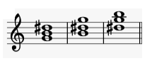

Example 9. The first Augmented Triad and its Inversions

In order to consider each key area with its properties, the first augmented triad and its inversions were converted into enharmonic equivalents, as shown in *Examples 10a, 10b and 10c*. Not all enharmonic equivalents were used, but only these that resolve into a specific major or minor by smooth voice-leading. The same procedure is taken to treat the other forthcoming augmented triads in *Examples 14a* and *14b,* and *Examples 18a* and *18b.*

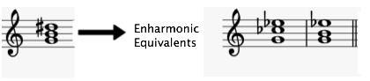

Example 10a. Enharmonic Equivalents of the First Augmented Triad (root)

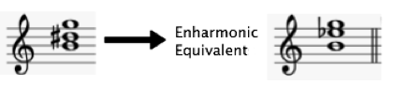

Example 10b. Enharmonic Equivalent of the First Augmented Triad (first inversion)

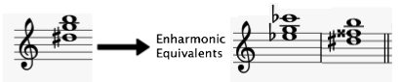

Example 10c. Enharmonic Equivalent of the First Augmented Triad (second inversion)

The first variant of alternate resolutions of the first augmented triad and its inversions shows how the bass of each chord becomes the first scale degree of the new major or minor, as shown in *Example 11a*. The following major and minors appear with such resolution of the augmented triad and its inversions: G+/g-, B+/b-, E-flat+/e-flat -.

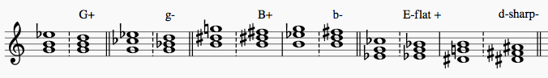

Example 11a. Alternate resolutions of the First Augmented Triad and its Inversions. The Bass of the Triad and its inversions is the first scale degree of a major or minor.

Arrival at other major and minor areas also could be found through other ways. However, for easier visual representation, I am considering the bass of the augmented triad with its inversions as a fifth to find new key areas. As shown in *Example 11b*, the following majors and minors emerge through this type of the alternate resolution: E+/e-, C+/c-, A-flat+/a-flat-.

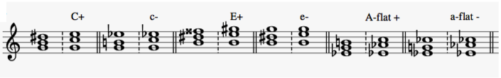

Example 11b. Alternate resolutions of the First Augmented Triad and its Inversions. The Bass of the Triad and its inversions is the fifth of the major or minor.

We can see that these many resolutions open the door to new harmonic possibilities. *Figure 2* maps these potential key areas onto the Circle of Fifths.

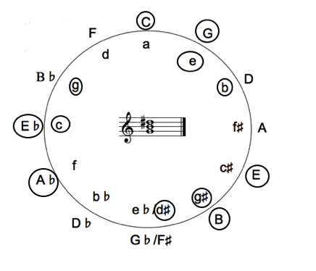

Figure 2. Map of Potential Key Areas Applied to the Resolution of the First Augmented Triad

2.B. The Second Augmented Triad

*Example 12* demonstrates the second augmented triad of the derived set, B-flat – D – F-sharp and its inversions.

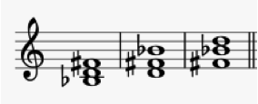

Example 12. The Second Augmented Triad and its Inversions

Enharmonic equivalents have also been chosen for the second augmented triad to show the relationship to the majors and minors as shown in the *Examples 13a, 13b and 13c*.

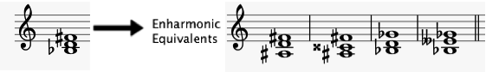

Example 13a. Enharmonic Equivalents of the Second Augmented Triad (root)

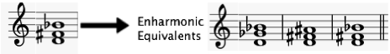

Example 13b. Enharmonic Equivalents of the Second Augmented Triad (first inversion)

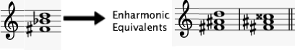

Example 13c. Enharmonic Equivalents of the Second Augmented Triad (second inversion)

*Examples 14a* and *14b,* and *Figure 3* apply the method of alternate resolutions to the second augmented triad of the derived set. As shown in the *Example 14a,* the following majors and minors emerge through the first type of the alternate resolution: B-flat+/b-flat-, D+/d-, F-sharp/f-sharp-.

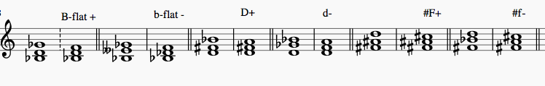

Example 14a. Alternate resolutions of the Second Augmented Triad and its Inversions. The Bass of the Triad and its inversions is the first scale degree of a major or minor.

As shown in the *Example 14b*, the following majors and minors emerge through the second type of the alternate resolution, when treating the bass of an augmented triad and its inversion as a fifth: E-flat+/e-flat-, G+/g-, B+/b-.

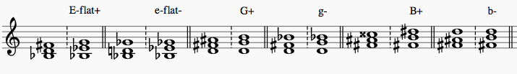

Example 14b. Alternate resolutions of the Second Augmented Triad and its Inversions. The Bass of the Triad and its inversions is the fifth of a major or minor.

The potential majors and minors of the alternate resolution of the second augmented triad are shown on *Figure 3*:

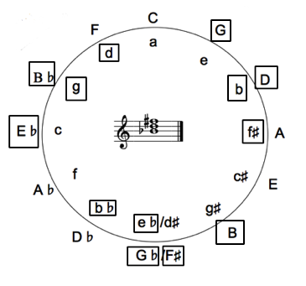

**Figure 3.** Map of Potential Key Areas after Resolving the Second Augmented Triad

*Figure 4* combines the results of this analysis of both triads, and demonstrates how resolutions of these two augmented triads assists the composer in exploring almost all twenty-four triads.

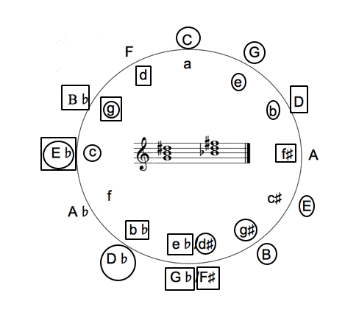

**Figure 4.** Map of Potential Key Areas Combined from the Resolution of Both Triads

3. Deeper exploration of distant keys

As we see, these first and second augmented triads, through their resolutions, visit most of the 24 tonal centers on the circle of fifths. However, there are still some key areas left untouched. Although they are not reinforced in this Introductory Theme, Shostakovich does not abandon them. There are six triads that are not accessed through the given augmented triad resolutions. However, these triads do make an appearance in the first movement of Shostakovich’s Second Piano Sonata. To explore them, the composer introduces a third augmented triad. This triad, C – E – G-sharp, is presented in the transition to the secondary theme in mm. 45-47, as shown in *Example 15*. (This transition actually features two augmented triads, but one of them was previously presented as part of the head-motive (E-flat-B-G). It does not need to be analyzed in its enharmonic version, in which it now appears.)

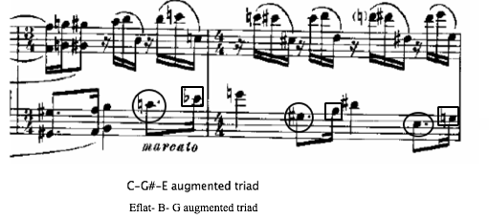

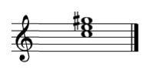

Example 15. Third Augmented Triad

This is one of the crucial moments in the movement, at the point when the lyrical primary theme finishes its final touches and converts into the forceful secondary theme. Therefore, the appearance of a third augmented triad in this episode is significant. It prepares the Secondary Theme while also serving as a reminder of the Introductory Theme’s mystical tonal language, which is comprised of distant tonalities linked by augmented triads. In addition, this third augmented triad, fills out the exploration of all twenty-four major and minor modalities. In theexamples below, the method of alternative resolutions is again applied to demonstrate the possible resolutions of this third augmented triad.

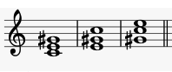

Example 16. The Third Augmented Triad and its Inversions

Enharmonic equivalents have also been chosen for the third augmented triad to show the relationship to the majors and minors, as shown in the *Examples 17a, 17b and 17c*.

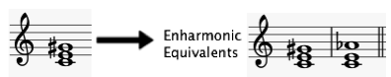

Example 17a. Enharmonic Equivalents of the Third Augmented Triad (root)

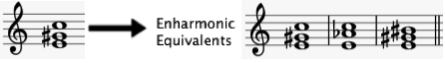

Example 17b. Enharmonic Equivalents of the Third Augmented Triad (first inversion)



Example 17c. Enharmonic Equivalents of the Third Augmented Triad (second inversion)

The first variant of alternate resolutions of the third augmented triad and its inversions creates the following major and minors: C+/c-, E+/e-, G-sharp+/g-sharp-, as shown in *Example 18a*.

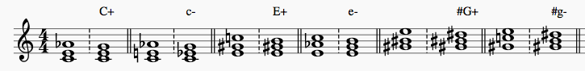

Example 18a. Alternate resolutions of the Second Augmented Triad and its Inversions. The Bass of the Triad and its inversions is the first scale degree of a major or minor.

As shown in the *Example 18b*, the following majors and minors evolve through the second type of the alternate resolution, when treating the bass of an augmented triad and its inversion as a fifth: F+/f-, A+/a-, A+, a-, C-sharp/c-sharp-.

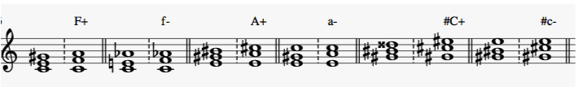

Example 18b. Alternate resolutions of the First Augmented Triad and its Inversions. The Bass of the Triad or its inversions is the fifth of the major or minor.

*Figure 5* then plots the possible resolutions to each key area from all three augmented triads.

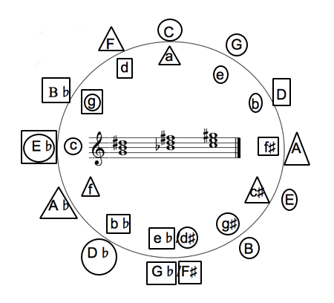

**Figure 5.** Map of Key Areas Applied to the Resolution of all Three Triads

With the addition of the third augmented triad, Shostakovich opens the door to his enchanting tonal exploration: these three triads and their enharmonic versions come to resolve to all 24 major and minor triads at some point in this first movement. Thus, they form the harmonic underpinning for a radical, post-tonal approach to music. Fundamentally triadic in nature, but without any traditional harmonic hierarchies, this first movement is both brilliant and befuddling for the performer.

When analyzed according to the resolution of these augmented triads, suddenly, the distant relationship key areas do not seem quite as bizarre. Therefore, the centricity of conventional harmony (tonic — subdominant — dominant) does not have any weight in the movement, which should not be analyzed according to traditional models. Rather, the manifold floating tonalities provide more of a coloristic interplay between themes and their elements, so that when the secondary theme enters in E-flat major, the tonality carries more of a symbolic sense for Shostakovich (which will be discussed later), and should not be analyzed for its relationship to the main tonality of B minor.

ii. Theoretical Analysis: Second Movement

While the opening movement created tension through harmonic density and chromatic motives, the second movement is much simpler in its harmonic exploration. Instead, Shostakovich creates tension through registral and textural opposition and through the juxtaposition of varying genres and styles. The formal structure of the movement follows the ABA¹ pattern. However, within that macro-level form, there are many non-traditional formal elements. What begins as a slow waltz is altered by march-like elements. The following analysis treats each formal section in sequence, investigating the transformation that occurs as one set of genre-specific expectations takes over from another. The formal outline of the second movement is:

Section A: measures 1-45

Section B: measures 46-73

Section A1: measures 79-133

Section A

The movement opens with a lonely, independent melody with a waltz-like lilt. While this melodic line is agitatedly seeking its place in the movement, the left-hand accompaniment is slowing it down with steady pulsating chords. These strict march-like chords in the left-hand wrestle with the spontaneous melody (*Example 19*).

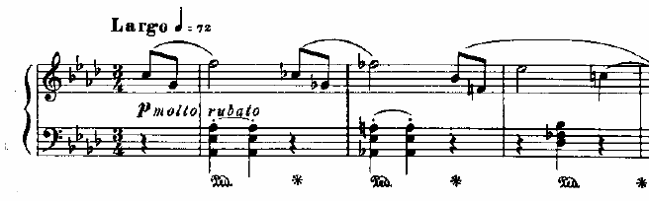

Example 19. Second Movement. Measures 1-3

These polar elements of the thriving melody and the fate-like chords eventually break the inner rhythm of the dance. This distinction between the lively impulsive dance melody and concise chords’ fate-like knocks is semantically important for the sonata, and lends the movement to a narrative interpretation.

Section B

In the B section, the intimate monologue of the first part merges from A-flat major (as indicated at the beginning, but tonally expanded to include chromatic tonalities) to C major in the second part. While the melodic line of the first part was reaching to different registers and seeking its place in the movement, when it emerges to the second part of the melodic line, which was heard in the first part, it is almost freezing. While in the first part this lonely waltz-like melody is independent and written metrically and rhythmically freely (indicated with ‘molto rubato’, ‘espressivo’, ‘poco accelerando’), in the second part the robust expression of the march-like chords determines the character, flow and structure of the melody. While the first part of the second movement introduces elegant and playful ballet-like dance, the middle section is twice slower, giving a sense of stopped time. The tonic pedal chords in C major become the core of the steady metric and rhythmic flow, where march-like steadiness turns the melody into a constrained and more robust line.

Section A¹

The third and final formal section is written in a 3-layer texture with independent registers and colors. The nature of the melodic line in this part of the movement is exploratory and free as in the first part, but now Shostakovich uses the compositional technique of canon, so that the lyrical theme of the first part turns from the innocence of the single naïve line of a waltz-like character into an enchanting series of phrases with a “mirage”-quality. As the melody continues, more “mirages” appear through the extravagant arpeggiated passages, which ascend and descend on the *ppp* across the keyboard with the first instance of it in m. 95-97 (*Example 20*).

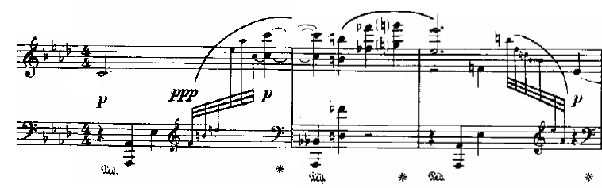

Example 20. Allusions of "mirages" through the arpeggiated passages in the final section of the Second Movement

This part almost becomes a collection of the elements that the movement already obtained from the first and second parts, such as the independent line and free meter in the first part and the strong prevalence of the fate-like chords and strict meter in the second part. While in the first two parts of the movement these elements were represented as contrasting elements, here they are intertwined. The fate-like chords here depicted as reminiscences of a dark, second part of the movement now prolonging the ends of the small units of melodic phrases, and letting the sound of the melodic canon mesmerizingly disappear before the next series of mirages (See *Example 21*).

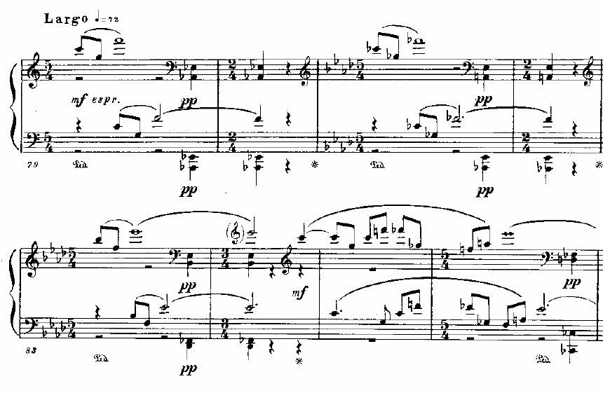

Example 21. Another Type of "Mirages" in the Final Part of the Second Movement

These unique combinations of genres and styles, juxtaposed with extremes in register and dynamics, demand an imaginative and creative performance. While it is not difficult to find opportunity for expression and virtuosic display in the execution of such dramatic music, it is a considerable challenge to craft a coherent performance that rises above superficial showmanship.

iii. Theoretical Analysis: Third Movement

Shostakovich rarely chose the form of theme and variations for his compositions. The few instances from his catalogue that do exist were mostly written in the 1940s, and include the third movement of the Second Sonata. This form was also used in his second string quartet—composed the following year. In many ways, this form is a difficult vessel for the composer’s mature style; his melodic structures tend to be motivic in nature, yet long and rambling. By way of comparison, Shostakovich’s Op. 3 variations for orchestra are treated with very compact thematic material, making the variation technique the foreground of the piece. Although this theme is characteristically long, it is written in cut time and follows very clear classical structures. By contrast, the theme from the Second Sonata could never be considered either “compact” or “classical.” Its nature is rambling and fails to fit into any recognized classical thematic forms. Instead, it is through-composed, with frequent repetitions and transpositions of motivic fragments.

Further complications for the performer and listener alike arise from the fact that this theme is not as effectively executed at the piano as perhaps it would be on a stringed instrument or voice. For example, the song cycle *Six Romances to Verses by English Poets*, Op. 62, features similar motivic moments: large intervallic leaps, frequent directional shifts at slow tempos, displaced metrical accents, a dark character in minor tonality, and an overall rambling aesthetic. However, when set for voice, this type of melodic material is expressive, and its rambling nature gives the performer a chance to manipulate each pitch with subtlety. On the piano, similar thematic writing, as present in the Second Sonata, is difficult to execute; without the tools of vibrato and dynamic shading on sustained tones, it is easy for the contour of the melodic line to get lost, especially at the slow tempo of *Largo* that Shostakovich indicated. Additionally, the predominant dynamic markings are *piano* and *pianissimo*, making the job of the pianist that much more difficult on an instrument that has no control over sustained tones.

In the analysis that follows, I will focus primarily on the theme, rather than exploring the techniques used to vary it, with the expectation that a successful performance of this movement requires an expert understanding of the thematic material upon which the entirety is based.

The theme of the Second Piano Sonata stands out first for its length and slower tempo (*moderato con moto*). At thirty measures, this unaccompanied melody is difficult to perform in a manner that maintains the audience’s interest. The entirety of the theme occupies the soft dynamic regions and has a limited range, fitting almost entirely within the two octaves above middle C. The melody is also distinctly declamatory in style; it features no pianistic runs or arpeggiations, often stressing repeated tones and never leaping more than an octave.

The melodic landscape is also uneven. The tranquil flow of the opening perfect 5th is further interrupted by the interplay between 4ths and tritone intervals, and tense major 7th leaps.

The performance decisions are affected by the theme’s unpredictability, unevenness and tension. The melodic range is no more than one-and-a-half octaves, which suggests minimum use of pedal. However, the expressive execution of the motives and intervallic interplay is puzzling. The choices that a pianist needs to make are toward dynamic structure, pedal and tone expressiveness. When it comes to tone, a pianist is faced with two questions: which intervals should be played stronger, and which motives should be more active in its dynamic development? Since we are dealing with intervallic relationship, we ought to use intervallic resolutions, which are also narrative in nature and can help with the phrasal structure.

First, to resolve the problem of phrasal direction and organic distribution of dynamics within this long melody of thirty-one measures, it is important to observe the melodic canvas of several chromatic-like motives repeated throughout the theme, as shown in *Example 22*:

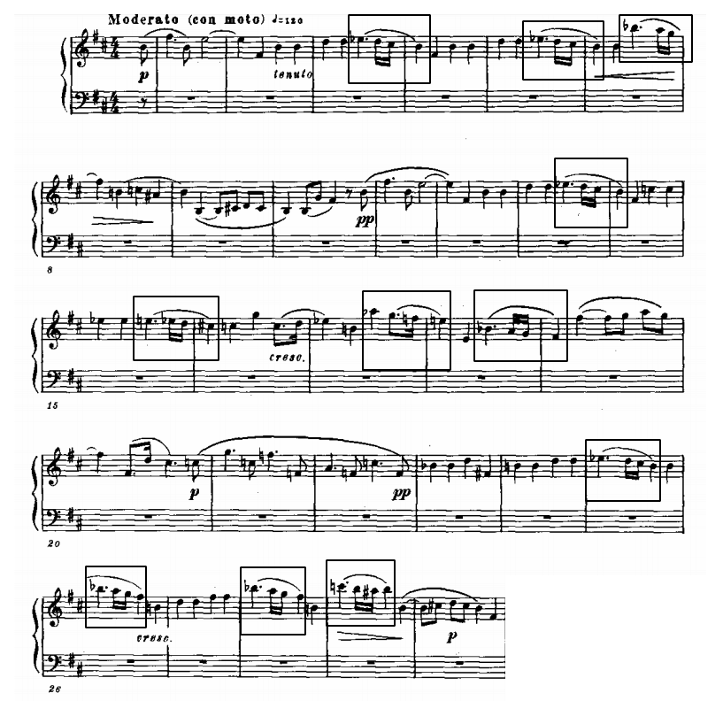

Example 22. Chromatic Motives of the Opening of the Third Movement

These micro-passages consist of descending seconds and diminished intervals with scalar descents in the pattern half-whole-half, bringing dramatic expressiveness to the theme.

Instances of each of these motives are listed in *Example 23*.

Example 23. Outline of the Six Lament-like Motives in the Opening of the Third Movement

Motive 1:  in measures: 3-4, 5-6, 13-14, and 25,

Motive 2: 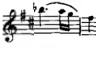 in mm. 7-8, 26,28

Motive 3: 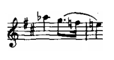 in mm. 17-18

Motive 4:  in mm. 15-16

Motive 5: 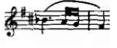 in mm. 18-19

Motive 6: 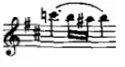 in m.29

Looking further into the sequence of motives of the Second Piano Sonata’s third movement, one can notice their similarity. They grow from the first motive (which first appears in m. 3) and constitute its variations. Deeper analysis of this motive reveals that it is a variation of the D-S-C-H motif, a musical cryptogram of the composer’s name. As in German musical notation that Russians often operate with, D, Es, C, H stands for the composer’s initials in German transliteration: D. Sch, as shown in *Example 24*:

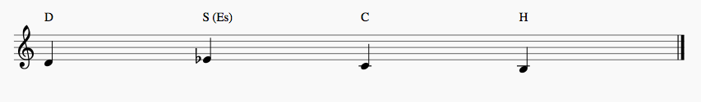

Example 24. D-S-C-H motive cryptogram

The composer often used the cryptogram of his name as a motive for various compositions, such as Tenth Symphony, Sixth, Seventh and Eighth Quartets to name a few[11]. The pitches of the motives 2,3 and 5 mentioned in *Example 23* are variants of this construction (*Example 25*):

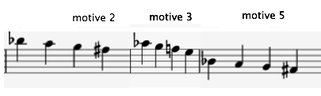

Example 25. Transposed Variants of the D-S-C-H Motive

However, motives 4 and 6 are different from the DSCH combination and its variants. The pitches of these motives are shown in the *Example 26*.

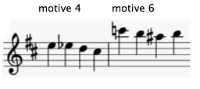

Example 26. Further Related Variants of the D-S-C-H Motive

They are the variants of another common cryptogram (*Example 27*):

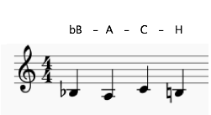

Example 27. B-A-C-H Cryptogram

Each of these cryptographical motives occurs at a climactic moment within its phrase. Through Shostakovich’s vocal and instrumental works of the 1940s, important motivic units are often positioned at the most dramatic points of the musical context. These musical moments function symbolically, and the Second Piano Sonata’s third movement harbors no exceptions. The descending motives of the third movement’s theme point to key phrasal climaxes, and performers should shape their playing around them in each instance.

Below is a visual map representing one version of expressive performance of the Theme (*Example 28*).

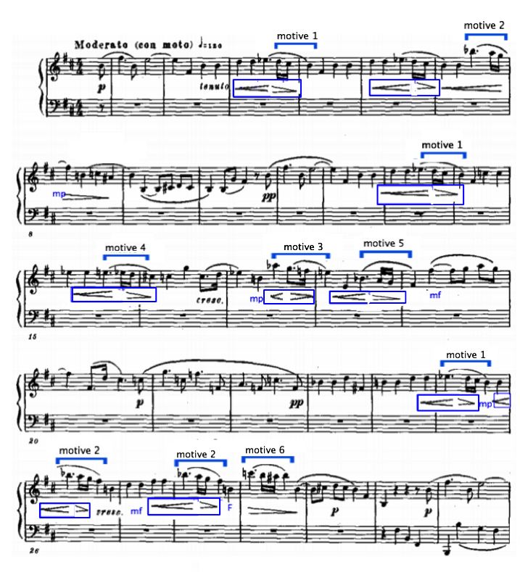

Example 28. Suggestions on Expressive Interpretation of the first thirty measures of the Third Movement Opening

The hairpins that are boxed in a blue color are my indications. The dynamic signs boxed in blue and signs in blue are my additions. Based on the comparison with the vocal works, where the first note of the descending motif is emphasized, I marked the score similarly. Mastering the phrasing of this theme is an essential first step for any competent performance of this movement. Each variation that follows will utilize the same strategy. By mapping the performer’s phrasing according to the cryptographic motives, one can begin to make sense of this very long, difficult phrase.

iv. Interpreting the Technical Requirements of Shostakovich's Piano Sonata No. 2

To have a better grasp of Shostakovich’s pianistic approach and the technique that is required for an expressive and versatile performance, it is necessary to look at the composer’s own pianism and technical assets. Thanks to archival footages, audio and video recordings of the composer’s own performances are widely available, and offer insight into the composer’s pianistic approach. Utilizing these recordings, Denis Plutalov[12] has conducted a very valuable analysis that looks into the composer’s interpretative decisions in performing his 24 Preludes and Fugues. In support of my research I used both sources, the recorded material and the research done by the Plutalov, which helped me to trace the general pianistic tendencies of the composer and apply them to the Second Piano Sonata.

At the age of nine, Shostakovich began to study with Ignatiy Glyasser, a student of Theodor Kullak and Hans von Buelow. The pianistic style that Glyasser acquired from his previous pedagogues involved “a precise finger action that combined a natural attack of the key with a strictly horizontal wrist.”[13] Considering that this foundation was instilled in him as primary, it can serve as a natural reference to the technical approach of the first movement: brisk and well-articulated passages without excessive wrist movements. As a pupil of Leonid Nikalev (the sonata is dedicated to him), Shostakovich inherited two approaches to the piano key: pressing the key with a great weight of the arm, and pushing the key.[14] The first approach allows for infinite tone exploration due to the careful regulation of the arm’s weight and control of the speed of pressing and exiting the key. The second approach allows for a quick and strong attack providing a very sharp sound. In Nikolaev’s studio, Shostakovich was fully immersed in the process of developing prolongated phrases with the movement of the whole hand. “One of the main principles of Nikolayev's school was the idea that at the beginning of the phrase the hand goes down onto the keyboard, not leaving the keys until the last note of the phrase.”[15] This type of motion refines the phrase from broken fragments, shaping wider musical phrases. This idea organically translates into the phrase structure of the first movement, where the accompaniment of the exposition is prolonged for its entire length of 43 measures.

Another trait that Shostakovich inherited from the Nikolayev’s studio is his “anti-romantic approach towards bringing too many extra nuances into musical performance, thus sentimentalizing it. He was particularly famous in the conservatory for his quote, ‘I can’t stand a performance decorated with nuances!’”[16]

It is in Nikolayev’s studio that Shostakovich met Mariya Yudina, a charismatic and influential pianist, often an assistant to Nikolaev during his leaves. She enhanced Shostakovich’s views on 0piano technique and opened the door to the modern repertoire of Hindemith and Stravinsky. She also offered a new interpretation of music of J.S.Bach, where her tone was influenced by the amount of arm weight and speed of entering and exiting the key. She would mention: “I heard how each part actually has its own timbre, although this is theoretically impossible.”[17] She taught a highly articulated touch and a deep mergence into the key in slow tempos.

Shostakovich’s own piano style, formed under the guidance of such pedagogues, was described as "very direct, without much plasticity, and very laconic in expression. It was altogether idiosyncratic manner of playing."[18]

According to Moisei Weinberg, Shostakovich's composition student and an accomplished pianist himself, “Shostakovich's interpretations can be considered exemplary in regard to tempo, character, and grasp of the structure. They bear the images and feeling of the composition as conceived in his mind.”[19]

In the video recording of Shostakovich’s performance of his first piano concerto, at the end of the fourth movement marked *Allegro con brio (piano solo)*,[20] it is especially visible how the composer’s body motion is minimal, with a straight posture without leaning toward the keyboard, allowing for the application of the maximum amount of arm’s weight. The well-articulated furious technical passages of the first movement of the Second Piano Sonata could be compared to the passages in the *Allegro con brio* section of the fourth movement of the concerto. This technical approach of a strict posture, fully relaxed arm and breathtaking fingerwork in the concerto could be applied to the performance of the first movement of the sonata, which is written without exaggerated nuances. Observing such straightforward technical anticipation, it could be argued that since these virtuosic passages are minimalistic in their offering, they dictate the nature of the melody. If the melody existed unaccompanied, it could have been projected more as a song-like melody, but with the mechanical function of the accompaniment it is directed as a steady strict march. Therefore, the technical approach to the versatile performance of the first movement comes to a reserved body motion and strict fingerwork.

Plutalov found that while the composer almost never allowed tempo fluctuations or exaggerations in dynamics or articulation, he generally performed fast pieces faster (Fugue in A minor, Prelude in G major) as virtuosic showcase pieces, and slow pieces slower as meditative and reflective in character works (Fugue in C minor). Often, performers feel obliged to follow the exact metric indications, not considering them as just suggestions or opening remarks about character and form. It is important to remember that since there are colorful mosaics of tempi gradation throughout the whole sonata, there is a wide field for the performer to experiment with the interpretation of even more contrasting fluctuations between tempi, finding the balance in striking characters and formal structure.

Plutalov noticed that while Shostakovich’s sense of musical phrases tend to be anti-romantic, he “masterfully injects small *ritenutos* from time to time, which greatly enhance the sense of form communicated through his performance.”[21]This interpretative tendency of the composer could especially be used as a reiteration of the contrasting A and B sections of the second movement. While the first section of the second movement, *Largo*,is marked with such indications as *molto rubato, poco accelerando, ritenuto, a tempo, piu mosso, espressivo* it exaggeratedly conveys a relaxed and romantic feel. With the transition from this dreamy section to the rigid, detached B section, it becomes clear that the play of tempo markings is purposefully set to emphasize the structure of the form and the contrasting characters within. Therefore, the contrast between the romantic and dreamy atmosphere of the first and the last sections of the movement could even be more exaggerated through the tempo fluctuations, which would support the contrasting form of the movement better: meditative and reflected outer sections and a strict lifeless middle section.

As Plutalov noted, emphasizing the vertical harmonic relationship of voices is one of the most important aspects of Shostakovich’s pianism. He mentions that Shostakovich “frequently omits ties between notes in order to reveal dissonant, unresolved harmonies—thereby highlighting their role in creating harmonic tensions in the development of the piece. Such an effect could never be achieved by following the composer's own ties, indicated in the score.”[22] Such an approach could be applied in performative decisions of the third movement of the sonata to project depth of the lower register of the piano and bring harmonic tension (*Example 29*):

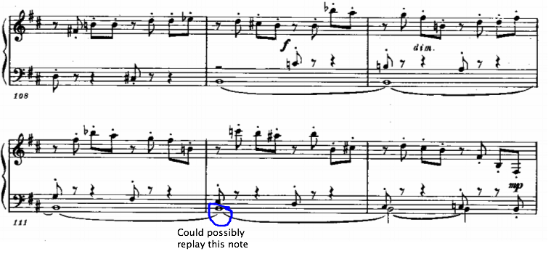

Example 29. Possibility of registral prolongation through the replay of the bass

Plutalov also noted that another approach the composer uses to interact with voices and texture in the performance is to play some chords in arpeggiated fashion. “For instance, in the F sharp major Fugue, Shostakovich uses a slight arpeggiation in the right hand in order to emphasize the theme in the alto part in mm.61-62 (the arpeggiation is marked by using small ties)” [as shown in *Example 30*]:[23]

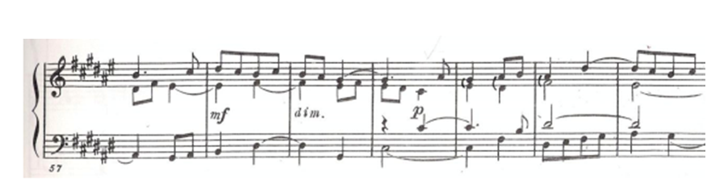

Example 30. An Added Arpeggiation to the Top Two Voices to Emphasize Theme in the F sharp major Fugue from Op. 87

Similarly, the second movement of the Second Piano Sonata could be explored with the arpeggiation technique in mind, where voicing and tone can reveal different sound effects and play between light and dark tonal expressions. In the example below from the second movement Section A, the larger intervals marked in the blue ink could be explored with the possibility of arpeggiation. An outlining of the certain voices can emphasize significance of the lament-like motives and offer more of an orchestration-like approach, rather than just a coloristic approach (*Example 31*).

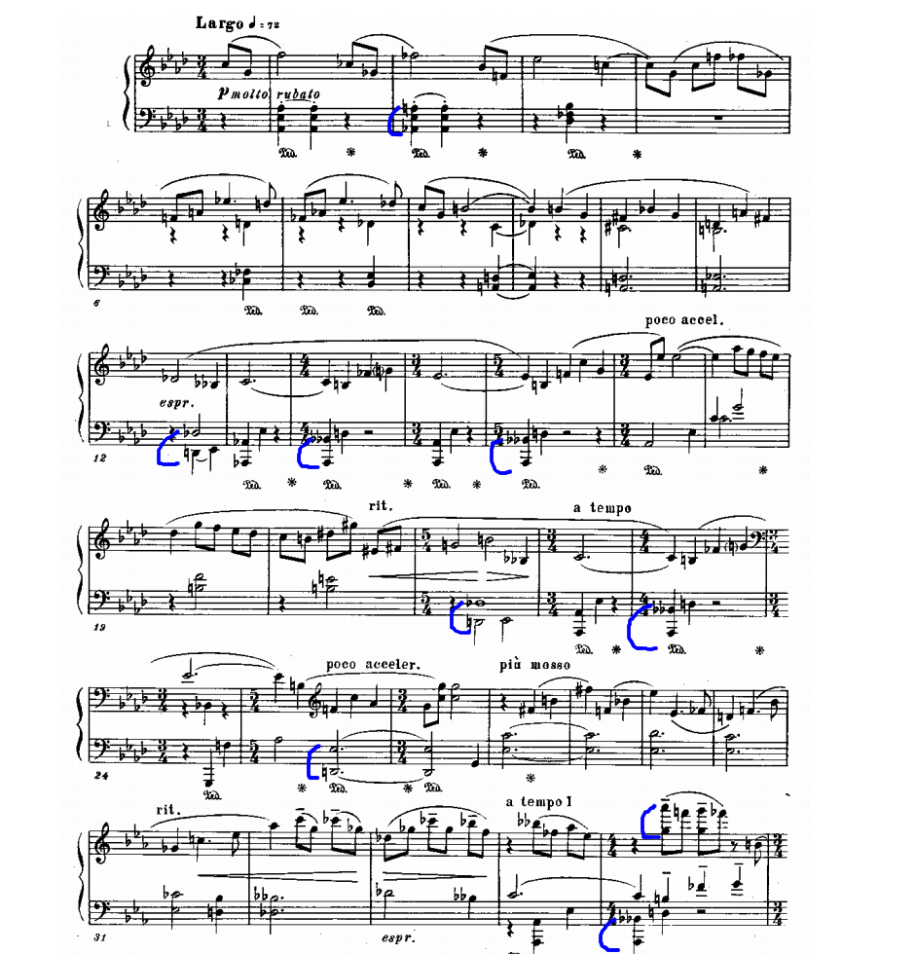

Example 31. Possible Adding of the Arpeggiation to the Opening of the Third Movement

CHAPTER THREE: IMAGERY, PROGRAM, AND THE ART OF CRAFTING A PERFORMANCE

Shostakovich’s Second Piano Sonata remains relatively unknown because it is rarely performed. This lack of frequent performances stems from the fact that it is a difficult piece for both pianists and audiences. A successful performance of the work requires an understanding of Shostakovich’s musical syntax, tonal language, formal structure, and timbral dialect. In addition to grasping these technical aspects of Shostakovich’s compositional technique, the performer needs to leverage them to interpret composer’s unique abstract style. This leaves a performer with two tasks: mastering theoretical analysis of the piece and transferring that knowledge to the imaginative sphere.

In the preceding analysis, I have addressed technical and theoretical issues in the piece. In this final section I will address how the performer can use this knowledge in conjunction with other creative extramusical sources of inspiration and imagery to craft a compelling narrative. Although there is no convincing case for any intended program on Shostakovich’s part, we can use extramusical connections to aid in the successful interpretation of this largely inaccessible work.

Methodology

The first objections to the use of a program in analyzing Shostakovich’s Piano Sonata No. 2 will likely center on the composer’s own denials of any extramusical inspiration. The question of how faithful a performer must remain to a composer’s approach has been widely contested. Perhaps the most definitive word on the subject, however, comes from Richard Taruskin’s seminal work *Text and Act*.[24] In it, Taruskin approaches the question of performance practice from several different perspectives in a series of essays. In the first, Taruskin addresses the question of early music performance, for which key information regarding the composition, premiere, and composer are often missing. He heavily critiques “reconstructionist performers” whose main, and sometimes only, goal is simply “getting it right” according to the historical record, rather than structuring an imaginative and convincing performance. He states: “The most authoritative and compelling reconstructionist performances of old music, as well as the most controversial, have always been those that have proceeded from a vividly imagined—that is to frankly say imaginary—but coherent performance style.”[25] If a coherent and well-researched program assists the performer in achieving that vividly imagined performance, then it becomes a great tool in freeing the music from the page and letting it “speak for itself,” as Taruskin so passionately encourages.

Russian piano pedagogy itself is steeped in the practice of encouraging imagery in students from a very young age. In a work as complicated as a sonata, students are often encouraged to assign characters, settings, and ideas to each theme, assisting even the youngest players in structuring a cohesive approach to lengthy works. Narrative structures are particularly helpful when approaching a sonata. That the work was not conceived of in a narrative sense is of no consequence to the manner in which it is analyzed by the performer. In fact, narrative criticism is an approach used widely in the world of rhetorical studies to explain and examine a variety of media: from the more obvious novels, plays, and films to the less obvious such as speeches, paintings, and even music. As rhetorician Sonya K. Foss explains, “Narratives organize the stimuli of our experience so that we can make sense of the people, places, events, and actions of our lives.”[26] This paper will conduct a narrative analysis of the Second Sonata by overlaying Chekhov’s “The Black Monk,” and in so doing facilitate an informed and vivid performance.

I am not the first to ascribe programmatic connections to Shostakovich’s abstract compositions. Although Shostakovich’s music is largely abstract, it has long been associated with extramusical historical events. In the post-World War years musicologists started to describe his grim symphonic and instrumental music as programmatic—as music that included coded messages. Even though the composer did not explicitly outline any program for the music written during the Second World War, many researchers have tried to decode his music, and often believed they were “unveiling” the composer’s reaction to Stalin’s regime, assigning symphonic themes different characters (fascist theme, people’s theme, bomb theme).

Therefore, the music of Shostakovich in Russian musical criticism became a monument of the war’s events that was taught in all of the public music schools across the Russian nation. Even though this nationalistic approach could provide a historical background for the time period in which the music was composed, it does not necessarily help a modern performer to create images and associations that are relevant to his/her life experience. In addition to not being actively constructive, this association can actually be detrimental to the performer, boxing him/her into one stereotypical narrative: The tragedy of the Russian experience in the World Wars. As a performer, I found myself questioning what my role was in bringing to life this music: was it just to retell the story of the war?

Belonging to the post-World War II generation, I wasn’t actively affected by the war events and only experienced it through my grandmother’s memories, told to me as stories. When I approached the Second Sonata, this World War narrative was difficult to relate to and did little to help me understand the complex structures, meandering melodies, and rapid harmonic rhythm found throughout the work. I discovered that I needed a new narrative to process the work.

I began reading through the letters of Shostakovich in search of insight into his compositional process. During the time he was working on the sonata, he wrote that he was taking a break from composition. He viewed the sonata only as a “miniature, impromptu” work and described himself as taking a “pause” from composition during this period. Other letters written within the same year mention Chekhov’s story “The Black Monk,” and he also published an article in 1943 describing the story as being constructed in sonata form.[27]

I began investigating “The Black Monk” to see if there was a connection between the literary work that so preoccupied the composer during the time that he composed the Second Sonata. While I later found evidence that Shostakovich himself did not consider the story to be a program for his sonata, I did discover that many of the characters and themes from Chekhov’s work influenced my interpretation of the piece. Therefore, “The Black Monk” became a narrative, or external program, that—though not intrinsically related to the Second Sonata—greatly aided my understanding of the piece and produced a better performance.

This approach is not without precedent. As Carl Dahlhaus explains, Wagner laid out a program for Beethoven’s Op. 131.[28] However, that program, a “depiction of a day in the life of our hero,” is intended only in an “analogical,” not an “identifying,” sense. Readers will not recognize the merits of the interpretation so much while actually listening to the music—for in the immediate experience of it music is a “revelation from another world”—but when they are reflecting on the music after hearing it.

Dahlhaus remarks on a similar process in Mahler’s compositional approach. As he observes: “Mahler distinguishes between an ‘external’ and an ‘internal’ program.” [29]He gives the example of Mahler’s First Symphony, in which the third movement is marked *Marcia Funèbre*, but for which the inspiration was drawn from a children’s picture. The internal program is the general feeling and ethos inspired by those two words: *Marcia Funèbre,* while the external program is a specific image—a source of external inspiration that served an initial purpose, and then was discarded. Dahlhaus elaborates: “The ‘internal’ program . . . consists of a ‘process of sensation’ made of feelings ‘in the abstract’: ‘dark sensations.’”[30]

As Mahler himself explains: “At this point, the thing to be depicted is irrelevant—only the mood that is supposed to be expressed is relevant.”[31] Mahler then goes on to describe these programmatic associations as “signposts.” Dahlhaus rightly places these signifiers in their proper context: “The ‘signposts’ serve as a means of reaching an end, namely, an internal musical comprehension; and they fulfill their purpose in a merely preliminary way: ‘for the time being.’”[32]

If such signposts and signifiers can be useful to the composer, then so too can they be useful to a performer, who need not express them to the audience in order for the internal imagery they inspire to be audible. Thus, it can be concluded that the development of an internal program is a useful tool for a performer, even when such a program is not indicated by the composer. This development can be viewed as a two-step process: An external program becomes the catalyst for the creation of a deeper, internal program. All this translates into real audible differences in a performance.

In selecting my own external program for Shostakovich’s Piano Sonata No. 2, I settled on a literary inspiration. Growing up in a culture where language is valued as much as music, I came to love literature and learned to often associate a sound with a word or a literary image. Shostakovich also possessed that distinctly Russian predilection for the literary arts. In 1927 Shostakovich was given a questionnaire on his creative process, in which he defined literature as the most important among all other arts. He described his attitude thusly: “Above all a preference for prose literature (I don’t understand poetry at all and do not value it…): *Demons, The Brothers Karamazov*, and in general Dostoevsky; together with him Saltykov- Schedrin; and in a different category, Gogol…And then Chekhov…”[33] (As a native speaker myself, I have always found that Chekhov’s literature sounds like music to the Russian ear.) Indeed, in Russia, music and literature have long enjoyed a symbiotic relationship.

We have evidence of Shostakovich’s literary explorations surrounding the writing of the Second Sonata. In an article published in 1943, Shostakovich describes Chekhov’s short story “The Black Monk” as “one of the most musical works of Russian literature, written almost in sonata form.”[34] This article was published in the same year as the Second Sonata, implying at least a coexistence of both works within the composer’s subconscious.

Even if the Second Piano Sonata was not directly inspired by the story "The Black Monk", the story can still serve as a framework for exploring the otherwise impenetrable music of the Second Sonata. Just as Mahler dismissed the “thing being depicted” as irrelevant next to the mood it elicits, and just as Dahlhaus labeled a performer’s own program as “analogous,” so too can today’s performer acknowledge the value of an external program without assigning it any meaning to the compositional process.

The use of “The Black Monk” as an external program is further supported by the many analyses of the work as “musical.” In fact, the connection between Chekhov’s story structure and that of sonata form is so well documented that Bartlett explains, “Chekhov, who never deliberately sought to ‘compose’ his works in a musical way, achieved this so effortlessly.”[35] If literary scholars can assign musical forms to a story in an effort to better understand the work in question, then the reverse should also hold true. I argue that Chekhov’s story “The Black Monk” can serve as a valuable external program to Shostakovich’s Second Piano Sonata, providing the performer with a framework to better approach an otherwise opaque work. In my own performance of the Second Sonata, an analysis of “The Black Monk” infused my playing with vitality, imagery, and unique phrasing that would not have been possible had the work been approached solely on abstract grounds.

**i**. Biographical sketches of Chekhov

1. Chekhov’s life and works

Anton Chekhov is one of the most respected, known and beloved literary figures in Russia. He was born in 1860 and died in 1904, two years before Dmitry Shostakovich was born. The writer and composer never met, but similarly had an inborn gift for finding exact expressions for their characters. No details are decorative in their works, but a part of the larger complex concepts. They also had similar professional trajectories. Like Shostakovich, Chekhov had three periods in his literary career. Chekhov also started his early career (1880-1888) with short satiric pieces, mastering his hand in a character writing first, narrating about different individuals’ temperaments and their reactions to their circumstances through a short story genre. In his middle period (1888-1899), he advanced to larger, thought-provoking philosophically oriented writing, illuminating more complex features of his characters with details of the surroundings. This is the period when the “Black Monk” (1894) was written, among other works. In this stage, his object was to highlight conflicts within several characters that are brought together in an event. These characters are in a different life journey and have different perspectives. The only similarities they have are the surroundings they are brought into. He shows inner conflicts, but leaves it up to the reader to understand the causes and results of it. In his late years (1899-1904), he turned to the complex ideas that he enfolded through the genre of plays.

In his writing, attention to details and surroundings were goals in themselves. Each element or object was placed in order to show the internal drama of his characters. He could not stand redundancy or extra details that did not play a role in a story. According to his own principles, everything that takes place in the story has to be relevant and important to the drama. So he wrote: "One must never place a loaded rifle on the stage if it isn't going to go off. It's wrong to make promises you don't mean to keep."[36] Aiken is suggesting that when reading Chekhov, we no longer view the character objectively, but begin to see them “only as infinitely fine and truthful sequences of mood. That mood then becomes subjective, and we are brought into the lives of the character, instead of simply observing those lives as a spectacle.”

Chekhov picked events of daily life that would reveal the complexity of the inner state of his characters. T. S. Eliot named this technique an "objective correlative." A noted literary critic, Charles May, described it further as “a detailed event, description, or characterization that serves as a sort of objectification or formula for the emotion.”[37]

Chekhov’s literary language is often called ‘musical’. Several writers, such as Bitsilli, Bartlett, Fortunatov, O’Toole, Balabanovich and Stowell have written about it. “Balabanovich, for example, finds that Chekhov’s musicality lies above all in his “particular attention to the sound of speech and to the rhythmical side of narration.”[38] “Bitsilli demonstrates, [that the] story [“The Steppe”] contains an ‘alternation of images and suggestions which, in terms of structure, approximate a purely musical development of theme and counter-theme, frames by supplementary theme. The repetitions of image-symbols, epithets, indications of movement, sound and colors which create two complete images correspond in musical terms to the recurrence of melodies, chords, harmonies, keys and tempos.’ ”[39] [40] Bartlett observes that the “fundamental dimension of Chekhovian musicality” is his “unique approach to form.”[41] She also notices that “the painter Ilia Repin… saw ‘The Steppe’ as a kind of suite, with theme and variations,” while Kornei Chukovsky detected sympohonic qualities in such stories as “In the Ravine,” “A Case History”, “The Lady with the Little Dog,” “Rotshiled’s Fiddle,” “The Bishop,” and “The Steppe.”[42] [43] [44] Bartlett indicates that in “The Black Monk,” “It is perhaps in its constant shifts in narrative tone and in its contrapuntal tapestry of ambiguity, modulation, and inversion that we may discern a deeper correlation with the language of music… [It has] high level of irony contained within the narration [that] seems to point to the exposition of contrasting themes lying below as well as actually on the surface of the story.”[45] Shostakovich himself said, that “Chekhov… constructed his works the way musical ones are constructed. Naturally this wasn’t conscious, it’s just that musical construction reflects more general laws. I am certain that Chekhov constructed “The Black Monk” in sonata form; that there is an introduction, an exposition with main and secondary themes, development and so on.”[46] [47] “In “The Black Monk” the conflict of themes is sometimes introduced or developed in the space of a paragraph, and thus the basic structure of sonata form is played out many times in miniature within the course of the story.”[48] Bartlett remarks, that Chekhov consistently changed sentence length to “create a prose rhythm” and “arranged sentences within his paragraphs, and indeed the paragraphs themselves, in a deliberate way, following a pattern of exposition, development, and recapitulation, often expressed as statement, reflection, and conclusion.”[49]

ii. Intersections between Shostakovich and Chekhov

Chekhov and Shostakovich shared a mutual fascination with the subject matter of mental illness. The idea of megalomania—and other obsessive pathologies—is a common theme in much of the source material that Shostakovich treated in his works: in the satirical opera *Nose*, where a nose physically leaves the face of an official and develops its own life (1927-1928); in the orchestration of the opera *Boris Godunov* by Moussorgsky (1939-1940); and in the orchestration of the *Songs and Dances of Death* by Moussorgsky (1962) to name a few. In each of these works that treat the idea of obsession, a solid connection to literature is present. Chekhov, as a physician, treated many patients suffering from the long-term mental debilitation that was the result of rampant tuberculosis, a disease the author himself struggled with for at least half his life. For both men—as for many creative individuals throughout the late-romantic and early expressionist eras—mental illness was a dominant theme.

Chekhov’s “The Black Monk,” which deals powerfully with obsession and mental illness, was a particular favorite of Shostakovich’s. He planned several works based on the story, including an opera that was never completed. Volkov recounts Shostakovich as saying:

It’s a shame that composers seem to overlook Chekhov. I have a work based on motifs from Chekhov, the Fifteenth Symphony. It’s not a sketch for ‘The Black Monk,’ but variations on a theme. Much of the Fifteenth is related to ‘The Black Monk,’ even though it is a thoroughly independent work.

In addition to this claim that it served as an inspiration for the Fifteenth Symphony, Volkov also states that Shostakovich intended a far more literal piece based on the story, citing the composer as saying:

I am definitely going to write the opera The Black Monk. I’m much more interested in "The Black Monk" than I am in The Gamblers. The subject has rubbed my soul full of calluses, you might say. I am certain that Chekhov constructed "The Black Monk" in sonata form, that there is an introduction, an exposition with main and secondary themes, development, and so on.[50]

This record of Shostakovich’s affinity for the story, taken with the contemporaneous article in which he describes “The Black Monk” as being crafted in a literary analog to sonata form, make it reasonable to explore a connection between the literary and instrumental works.

"The Black Monk"

Chekhov’s intricate short story “The Black Monk” shows a philosopher, Kovrin, who represents an intellectual superhuman. Chekhov reveals that such intellectual superiority can manifest itself more as mental illness than prowess. Kovrin hallucinates the image of a Black Monk, who visits him to tell him that he has a special mission in life and is exceptional. This vision greatly disturbs the philosopher’s wife and family, who cannot see the apparition to whom he speaks. However, Kovrin becomes attached to the idea that he has a special purpose and refuses to consider that his visions are illusions, rather than divine. He becomes increasingly unstable throughout the story. As Kovrin is visited by the mirage more often, he falls victim to megalomania and insanity with increasingly drastic results. Eventually Kovrin dies alone, and his final moments are spent in blissful delusion as he sees the Black Monk for one last time.

The impetus of Chekhov’s story is the legend of an illusionary Black Monk, as his main character describes:

“I have been all day thinking of a legend," [Kovrin] said. "I don't remember whether I have read it somewhere or heard it, but it is a strange and almost grotesque legend. To begin with, it is somewhat obscure. A thousand years ago a monk, dressed in black, wandered about the desert, somewhere in Syria or Arabia. . . . Some miles from where he was, some fisherman saw another black monk, who was moving slowly over the surface of a lake. This second monk was a mirage. Now forget all the laws of optics, which the legend does not recognise, and listen to the rest. From that mirage there was cast another mirage, then from that other a third, so that the image of the black monk began to be repeated endlessly from one layer of the atmosphere to another. So that he was seen at one time in Africa, at another in Spain, then in Italy, then in the Far North. . . . Then he passed out of the atmosphere of the earth, and now he is wandering all over the universe, still never coming into conditions in which he might disappear. Possibly he may be seen now in Mars or in some star of the Southern Cross. But, my dear, the real point on which the whole legend hangs lies in the fact that, exactly a thousand years from the day when the monk walked in the desert, the mirage will return to the atmosphere of the earth again and will appear to men. And it seems that the thousand years is almost up. . . . According to the legend, we may look out for the black monk to-day or to-morrow." "A queer mirage," said Tanya”, who did not like the legend.[51]

Chekhov described the story as a “medical novel, historical morbi”:

Being seen as a complex story of physical illness, it is not just a story of illness, it shows how a character sees and denies it. As the main character keeps having illusions of a Black Monk approaching him and telling that he is a superman, he believes in it and refuses to have a treatment, accepting his illness as the happiest moment of his life.”[52]

Anton Chekhov mentions in the letter to Suvorin that “I wrote the *“*Black Monk*”* without any depressing thoughts, with a cold mind. I just wanted to describe mania grandiose.”[53]

CHAPTER FOUR: Extramusical Inspirations for Shostakovich’s Second Piano Sonata

i. First Movement

Throughout the first movement, Shostakovich uses augmented triads to highlight the mystical nature of the movement, which creates unsettled and shifting moods. In Chekhov’s story, the Black Monk persistently appears and reappears, each time with a new message, just as these augmented sonorities appear and reappear, each time resolving to a new key area. Thus, if the performer treats Shostakovich’s triadic atonality in the first movement as an analogue to the apparition of the Black Monk in various new disguises, it will assist in accessing a level of timbral sensitivity so difficult to find in this dense musical context. It is essential that the pianist not get lost in a clutter of notes, but focuses on the larger formal sections of the movement instead. As each new augmented triad presents itself and melts away into the background of chaotic figurations, so too did the Black Monk appear in the hallucinations of Kovrin, directing his mania before disappearing again into the haze of the main character’s befuddled mind.

The featured emotive qualities of this first movement, if modeled after the first part of Chekhov’s story, are mystery, mania grandiose and obsession. In the story, the Black Monk becomes almost a sacred secret of Kovrin, and in different places with a new message each time. So too does the tonal language of Shostakovich’s first movement shift and modulate in a mysterious and secretive manner; each new tonicization is not presented with a clear and obvious harmonic progression, but is secretively buried in a mosaic of tonal mirages and their coloristic interplay.

And yet, within all of this mystery and intrigue, there is a hidden logic. While Chekhov’s story might seem to be mystical and bizarre, it is still what the author described as a “medical story,” which was created through the mystical legend. While the textural and harmonic language of the sonata’s first movement might seem inexplicable at first, its ambiguous tonal language is explained through the resolution of the three augmented triads where they almost become tonal centers.

The expressiveness of this opening movement depends not only on a firm understanding of the unique theoretical structure that underlies the music, but also on the performer’s ability to harness the esoteric and opaque sensibility so accurately portrayed by Chekhov’s narrative style. Mystery, obsession, mirage, and hallucination all meld with an almost unemotional and detached precision: The brilliant doctor gone mad, the carefully constructed phrase lost in its own hysteria.

ii. Second Movement

My evocation of the Black Monk imagery in the first movement is buried within the tonal language and textural structure, and therefore somewhat opaque, requiring the performer to make the imaginative leap connecting the character of the Black Monk and the augmented triads. However, the second and third movements present a much more accessible application of Chekov’s program. In short, if one understands the story, the music of these final two movements unfolds in a natural way for the performer. The second and third movements’ conflicts are expressed through the transformation and combination of various musical genres and forms. These juxtapositions and mergers are a perfect analog to the mirages in Chekov’s story, through which the main character experiences a dual reality. While the second movement intertwines waltz and march, the third movement features a wider array of genres through the theme and variations form.

The conflict between the impulsive waltz melody and the left-hand chords’ fate-like knocks is semantically important for the sonata, as it projects a mix of reality and illusion, just like when the sickness of the main character takes over his sanity in the story.

The lovely waltz of the second movement undergoes numerous transformations throughout. While at the beginning, the elegant theme is represented somewhat timidly, the evolution of the waltz reaches its dramatic zenith in the third part, which brings a new look to the dance-like quality of the movement, and carries strong resemblance to Chekhov’s story drawing on the idea of mirages.As in Chekhov’s story, where the main character begins his demonic ideas in the first part and becomes controlled by them in the second, in Shostakovich’s second movement the lively wandering melody of the first part gets controlled by the fate-like chords of the accompanying chords in the second.

In the third part of the movement, Shostakovich’s fantasy has translated Chekhov’s literary image of illusion into a musical series of mirages. Even when I try to think of this music as non-programmatic, the technique of canon that Shostakovich uses in this part of the movement reminds me of a depiction of mirages that Chekhov narrates in the story, especially when the main character recites a legend about the Black Monk. In the story, the main character employs a canon-like method to his retelling of the Black Monk legend:

A thousand years ago a monk, dressed in black, wandered about the desert, somewhere in Syria or Arabia. . . . Some miles from where he was, some fisherman saw another black monk, who was moving slowly over the surface of a lake. This second monk was a mirage. Now forget all the laws of optics, which the legend does not recognise, and listen to the rest. From that mirage there was cast another mirage, then from that other a third, so that the image of the black monk began to be repeated endlessly from one layer of the atmosphere to another. So that he was seen at one time in Africa, at another in Spain, then in Italy, then in the Far North. . . . [54]

Interspersed throughout the final section are sweeping arpeggios that explore extremes of register and dynamic range. These sparkling passages spanning across the full spectrum of the keyboard resemble the effect of a sudden blissful presence and departure of the Black Monk. It is reminiscent of Chekov’s story in which the image of the Black Monk spreads “endlessly from one layer of the atmosphere to another.”

The melody is projected through the series of colorful echoes scattered throughout the keyboard and therefore the originally elegant, somewhat impulsive theme becomes magnified in a multi-dimensional sense (e.g., mm. 104-109). The theme almost becomes delusional, opposite to its independent lyrical waltz-like character of the first part. The whole movement replies to the story’s plot, where the legend comes alive and illusion becomes reality for the main character: “From that mirage there was cast another mirage, then from that other a third, so that the image of the Black Monk began to be repeated endlessly from one layer of the atmosphere to another.”[55]

iii. Third Movement

The third movement hinges on the unpredictability, unevenness and tension present in the rambling theme. This theme (and its subsequent variations) is reflective of Chekhov’s writing style in “The Black Monk.”

This movement, more than any other, vindicates the use of extramusical interpretation, through its use of cryptogram. Shostakovich weaves long, rambling melodies out of tightly compact motives based on both his name and J. S. Bach’s. As we saw in the preceding section, breaking this incredibly long theme into its cryptographic motivic fragments can aid the performer’s understanding of how this unusual phrase was constructed. But to fully access the expressive potential of the music, an imaginative component is needed.

This final movement lends itself very easily to imaginative interpretation and a connection to extra-musical narrative. The unpredictability, unevenness, and rambling nature of the third movement’s theme creates a tension reflective of Chekhov’s writing style in his story “The Black Monk”. As Shostakovich varies the theme, each variation explores new genres and strange juxtapositions just as the second movement did. These elements are easily interpreted at the keyboard when the performer imagines the main character of Chekhov’s story. This character is defined by his megalomania and obsessive personality. He could never be represented by music that unfolds in symmetrical phrases or follows traditional formal structures. At the same time, there is something familiar in his personality and story. This is not the tale of an alien entity, but rather of a personality pushed to extremes, lost in delusion.

When performing, one should pay attention to the musicality of the motivic lines that are tucked away within abstractly shaped phrases. The sway of the dynamic shape of the phrases projects the moodiness of the main character as well as his unpredictable nature. All these extra-musical elements, such as mystical cryptogram unveiling, moodiness of the motivic elements and unpredictable sway of phrases should help a coherent performance.

CHAPTER FIVE: CONCLUSION

Performing Shostakovich at the piano is no easy feat. Beyond the rigorous technical demands on the pianist, this music requires a robust theoretical understanding of twentieth-century compositional techniques unique to the composer. In the Second Piano Sonata’s first movement, I outlined Shostakovich’s system of tonal exploration using augmented triads and their possible resolutions. In the second movement, I pointed to the composer’s manipulation of genre and form, and explored how the subversion of these expectations interacts with extremes in register and dynamics to maximize the coloristic potential of the instrument. In the final movement, I broke down the lengthy and difficult theme into its motivic elements, explicating Shostakovich’s use of the DSCH and BACH cryptograms.

Mastering the required technique and understanding the theoretical underpinnings of this sonata are essential first steps to a successful performance, but I do not believe that these hurdles are the reason this work is infrequently performed. After all, much of the piano literature carries similar demands and yet receives more attention. The inaccessibility of this work is due to the imaginative difficulty of interpreting Shostakovich’s aesthetic. More so than in his orchestral and chamber works, Shostakovich often worked out his most complex and opaque creative expressions at the piano. The Second Sonata is a perfect case in point.

While presenting an unsanctioned program to an audience or marrying a narrative to the music in strict terms would be ill advised, leveraging an extramusical source of inspiration is the final key to harnessing the full potential of this sonata. Through careful study, I selected Chekhov’s “The Black Monk” for such a project and have outlined here a potential avenue that a performer might take in crafting a coherent and expressive performance. Both Chekhov and Shostakovich share certain creative and aesthetic approaches that make this pairing prudent and effective. By exploring the Russian literature in which Shostakovich (a quintessentially Russian composer) was so immersed at the time of the sonata’s composition, key elements of his ineffable style are made more accessible. The narrative elements of “The Black Monk” that can be superimposed onto this sonata create cohesion and sense from an otherwise chaotic musical landscape.

This final approach of mapping the narrative of “The Black Monk” onto Shostakovich’s Second Piano Sonata should be viewed as a tool. By glimpsing the music from this perspective, the performer is bound to gain insight that will influence his or her phrasing and expression at the instrument long after the narrative has been discarded and forgotten. My hope is to influence future performances of this work by recommending my strategies and approach as outlined above.

Bibliography

Abraham, Gerald. *The Tradition of Western Music*. Berkeley, CA: University of California Press, 1974.

Balabanovich, E. “Chekhov I Chaikovsky.” *Moscow Worker* (1978).

Barlett, Rosamund. “Sonata Form in Chekhov’s ‘The Black Monk’.” In *Intersections and Transpositions: Russian Music, Literature, and Society*, edited by Andrew Wachtel. Evanston, IL: Northwestern University Press, 1998.

Barlett, Rosamund. “Rosamund Bartlett: From music historian to biographer and translator of Tolstoy and Chekhov.” By Alexandra Guzeva. *Russia Beyond*, October 8, 2014. https://www.rbth.com/literature/2014/10/08/rosamund_bartlett_from_music_historian_to_biographer_and_translato_40439.html.

Bitsilli, P.M. *Chekhov’s Art: A Stylistic Analysis*, translated by T.W. Clyman. Ardis: University of California, 1983.

Chekhov, Anton. "*The Black Monk"*, translated by R.W.C. Long. Brooklyn: Frederick A. Stokes Company, 1915.

Cohn, Richard. Audacious Euphony: Chromaticism and the Consonant Triad’s Second Nature. New York, NY: Oxford Press, 2012.

Dahlhaus, Carl. *The Idea of Absolute Music.* Chicago: University of Chicago Press, 1991.

Emerson, Caryl. “Shostakovich and the Russian Literary Tradition.” In *Shostakovich and His World*, edited by Laurel E. Fay. Princeton, NJ: Princeton University, 2004.

Fay, Laurel. *Shostakovich: A Life.* Cary, NC: Oxford University Press, 1999.

Foss, Sonya K. *Rhetorical Criticism: Exploration and Practice.* Long Grove: Waveland Press Inc., 2008.

Goldberg, Leah. *Russian Literature in the Nineteenth Century: Essays.* Jerusalem: Hebrew University Magna Press, 1976.

Hussey, William. “Triadic Post Tonality and Linear Chromaticism in the Music of Dmitri Shostakovich.” *Music Theory Online* 9, no. 1 (2003). <http://www.mtosmt.org/issues/mto.03.9.1/mto.03.9.1.hussey.html>.

Kuhn, Judith. Shostakovich in Dialogue: Form, Imagery and Ideas in Quartets 1-7. Burlington: Ashgate Publishing, Ltd., 2010.

May, Charles. “Anton Chekhov and the Modern Short Story,” Reading the Short Story. May 3, 2014. <http://may-on-the-short-story.blogspot.com/2014/05/short-story-month-cont-anton-chekhov.html>.

O’Toole, L. M. Structure, Style and Interpretation in the Russian Short Story. New Haven: Yale University Press, 1982.

Patel, Aniruddh D., and Joseph R. Daniele. "An empirical comparison of rhythm in language and music." *Cognition* 87, no. 1 (2003): B35-B45.

Plutalov, Denis V. "Dmitry Shostakovich's Twenty-Four Preludes and Fugues op. 87: An Analysis and Critical Evaluation of the Printed Edition Based on the Composer's Recorded Performance." Dissertation, University of Nebraska, 2010.

Shostakovich, Dmitri. “Mysli o Chaikovskokm.” Literatura I iskusstvo, 5 June 1943.

Stowell, Peter. “Chekhov’s Prose Fugue: ‘Sleepy’.” *Russian Literature Triquarterly* 11 (1975): 435-42.

Taruskin, Richard. *Text and Act: Essays on Musical Performance.* New York: Oxford University Press, 1995.

Temperley, Nicholas, and David Temperley. "Music-Language Correlations and the ‘Scotch Snap’." *Music Perception: An Interdisciplinary Journal* 29, no. 1 (2011): 51-63.

Volkoy, Solomon. *Testimony: The Memoirs of Dmitry Shostakovich.* New York: Proscenium Publishers, 2004.

Wilson, Elizabeth. *Shostakovich: A Life Remembered.* Princeton, NJ: Princeton University Press, 1994.

1. A. D. Patel and J. R. Daniele, “An Empirical Comparison of Rhythm in Language and Music,” *Cognition* 87, no. 1 (2003), B43.
2. Nicholas Temperley and David Temperley, "Music-Language Correlations and the ‘Scotch Snap’," *Music Perception: An Interdisciplinary Journal* 29, no. 1 (2011): 51-63. doi:10.1525/mp.2011.29.1.51.
3. Gerald Abraham, *The Tradition of Western Music* (Berkeley, CA: University of California Press, 1974), 62.
4. Rosamund Bartlett, interview by Alexandra Guzeva, “Rosamund Bartlett: From music historian to biographer and translator of Tolstoy and Chekhov,” *Russia Beyond*, October 8, 2014, https://www.rbth.com/literature/2014/10/08/rosamund_bartlett_from_music_historian_to_biographer_and_translato_40439.html.
5. Rosamund Bartlett, “Sonata Form in Chekhov’s ‘The Black Monk’,” in *Intersections and Transpositions: Russian Music, Literature, and Society*, ed. Andrew Wachtel (Evanston, IL: Northwestern University Press, 1998).
6. Ibid., p. 58.
7. Dmitri Shostakovich, “Mysli o Chaikovskokm,” Literatura I iskusstvo, 5 June 1943.
8. Ibid.
9. Richard Cohn, Audacious Euphony: Chromaticism and the Consonant Triad’s Second Nature (New York, NY: Oxford Press, 2012), 21.
10. William Hussey, “Triadic Post Tonality and Linear Chromaticism in the Music of Dmitri Shostakovich,” Music Theory Online 9, No. 1 (2003), http://www.mtosmt.org/issues/mto.03.9.1/mto.03.9.1.hussey.html.
11. Judith Kuhn, Schostakovich in Dialogue: “Form, Imagery and Ideas in Quartets 1-7” (Burlington: Ashgate Publishing, Ltd., 2010), 185
12. Denis V. Plutalov, "Dmitry Shostakovich's Twenty-Four Preludes and Fugues op. 87: An Analysis and Critical Evaluation of the Printed Edition Based on the Composer's Recorded Performance" (dissertation, University of Nebraska, Lincoln, 2010).
13. Ibid., 10.
14. Ibid.
15. Ibid., 11.
16. Ibid., 12.
17. Solomon Volkov, *Testimony: The Memoirs of Dmitry Shostakovich* (New York: Proscenium Publishers, 2004), 51-57.
18. Elizabeth Wilson, *Shostakovich: A Life Remembered* (Princeton, NJ: Princeton University Press, 1994), 58- 59.
19. Ibid., 15.
20. https://www.youtube.com/watch?v=zYOpnq6h_Ms
21. Plutalov, "Dmitry Shostakovich's Twenty-Four Preludes and Fugues op. 87.”
22. Ibid.
23. Ibid.
24. Richard Taruskin, *Text and Act: Essays on Musical Performance* (New York: Oxford University Press, 1995).
25. Ibid., 57.
26. Sonya K. Foss, *Rhetorical Criticism: Exploration and Practice* (Long Grove: Waveland Press Inc., 2008), 307.
27. Shostakovich, “Mysli o Chaikovskom.”
28. Carl Dahlhaus, *The Idea of Absolute Music* (Chicago: University of Chicago Press, 1991), 133.
29. Ibid., 138.
30. Ibid., 140.
31. Ibid., 138.
32. Ibid., 139.
33. Caryl Emerson, “Shostakovich and the Russian Literary Tradition,” in *Shostakovich and His World*, ed. Laurel E. Fay (Princeton, NJ: Princeton University, 2004), 184.
34. Shostakovich, “Mysli o Chaikovskom.”
35. Bartlett, “Sonata Form in Chekhov’s ‘The Black Monk’,” 70.
36. Leah Goldberg, *Russian Literature in the Nineteenth Century: Essays* (Jerusalem: Hebrew University Magna Press, 1976), 163.
37. Charles May, “Anton Chekhov and the Modern Short Story,” Reading *the Short Story*, May 3, 2014, http://may-on-the-short-story.blogspot.com/2014/05/short-story-month-cont-anton-chekhov.html.
38. Bartlett, “Sonata Form in Chekhov’s ‘The Black Monk’,” 60.
39. P.M. Bitsilli, *Chekhov’s Art: A Stylistic Analysis*, trans. T.W. Clyman (Ardis: University of California, 1983), 87.
40. He identifies “a basic tripartite thematic structure” in some stories stories, which comprises of a ‘statement,’ a‘reaction,’ and a ‘conclusion,’. This structure is equal to “exposition, crisis, resolution, and recapitulation.” Ibid., 101
41. Bartlett, “Sonata Form in Chekhov’s ‘The Black Monk’,” 61.
42. Ibid.
43. Peter Stowell “compares the structure of early story ‘Sleepy’ to that of a fugue.” Peter Stowell, “Chekhov’s Prose Fugue: ‘Sleepy’,” *Russian Literature Triquarterly* 11 (1975): 435-42.
44. Chekhov pointed to Korolenko “that a story he had written was like a good musical composition and declared on another occasion that his own story ‘Happiness’ was like a symphony.” E. Balabanovich, “Chekhov I Chaikovsky,” *Moscow Worker* (1978): 149.
45. Bartlett, “Sonata Form in Chekhov’s ‘The Black Monk’,” 64.
46. Volkov, Testimony: The Memoirs of Dmitry Shostakovich, 225.
47. This is corroborated by O’Toole in speaking about the parallelism and dynamism in the piece. L. Michael O’Toole, *Structure, Style and Interpretation in the Russian Short Story* (New Haven: Yale University Press, 1982), 174.
48. Bartlett, “Sonata Form in Chekhov’s ‘The Black Monk’,” 70.
49. Bitsilli, Chekhov’s Art: A Stylistic Analysis, 87.
50. Volkov, Testimony: The Memoirs of Dmitry Shostakovich, 223.
51. Anton Chekhov, *The Black Monk*, trans. R.W.C. Long (Brooklyn: Frederick A. Stokes Company, 1915). Ebook
52. Chekhov Letters 1892-1894, Moscow: Science (1977): 264. Translated by self.
53. Ibid., 265.
54. Anton Chekhov, *The Black Monk*, trans. R.W.C. Long (Brooklyn: Frederick A. Stokes Company, 1915). Ebook
55. Ibid.